الغلاف الخارجى للبحث

|  |  |  |  |  |  |  |  |  |  |
| --- | --- | --- | --- | --- | --- | --- | --- | --- | --- |
| أولاً: البيانات الخاصة بالطالب | | | | | | | | | |
| **الفرقة الدراسية** |  | | | **التخصص** | | |  | | |
| **اسم القسم** |  | | | | | | | | |
| **اسم المقرر** |  | | | | | | | | |
| **استاذ المقرر** |  | | | | | | | | |
| ثانياً: البيانات الخاصة بالبحث | | | | | | | | | |
| **عنوان البحث** |  | | | | | | | | |
| **طبيعة المشاركة** | **بحث فردى** | | | | | **بحث جماعى** | | | |
| **ارسال البحث** | **بواسطة البريد الالكتروني** | | | | | | | | |
| **اسماء الطلاب المشاركين فى البحث**  **(يكتب الاسم رباعيا)** | **م** | **الاسم رباعى** | | | | **رقم الجلوس** | | | **الرقم القومى** |
| **1** |  | | | |  | | |  |
| **2** |  | | | |  | | |  |
| **3** |  | | | |  | | |  |
| **4** |  | | | |  | | |  |
| **5** |  | | | |  | | |  |
| **تاريخ الإرسال** | **/ 6 / 2020** | | | | | | | | |
| ثالثاً: البيانات الخاصة بالكونترول | | | | | | | | | |
| **النتيجة** | | | **ناجح** | | **راسب** | | | | |
| **أعضاء لجنة تقييم البحث** | **الاسماء** | | | | | | | **التوقيع** | |
| **1** |  | | | | | |  | |
| **2** |  | | | | | |  | |
| **3** |  | | | | | |  | |

|  |  |
| --- | --- |
| **فى حالة عدم قبول البحث يرجى ذكر الأسباب** | * **..............................................................................................................................................** * **..............................................................................................................................................** * **..............................................................................................................................................** * **.............................................................................................................................................** |

**Project Name: Bike Store and blog**

**Team Information: Team 24**

***(typed not handwritten, except for the attendance signature)*:**

|  |  |  |  |
| --- | --- | --- | --- |
|  | **ID [Ordered by ID]** | **Full Name [In Arabic]** | **What he had done .**  **Include Parts 1,2 “until 11-L”,3** |
| **1** | 20180607 | مصطفي محمود سعيد | 1,2,8,9,11-e,11-j,11-l |
| **2** | 20180608 | مصطفي محمود عبد العزيز | 10-c,11-b,11-c,11-p |
| **3** | 2018494 | محمد رمزي فرج | 6,11-d,11-k, Part3 |
| **4** | 20180525 | محمد فتحي يوسف | 3,4,5,11-h |
| **5** | 20180527 | محمد ماهر فؤاد | 11-g, Part3 |
| **6** | 20180705 | يوسف خالد الجيوشي | 10-a,10-b,11-f,11-i, Part3 |
| **7** | 20180721 | يوسف مدحت جلال | 7,11-a |

Bike Store and Blog Project

1)Introduction

**a) Purpose.**

•online Bike and bike parts store that has listings of various bike along with their advantage and also consists of Bike service Registration.

•Online Bike Store and Blog Project is a combination of both sales and inventory management of the bike and bike parts.

• User can easily purchase bike or bike parts by using this system user does not have to come manually to shop to purchase the product.

•This system allows user to buy bike, bike parts and inventory online.

• System allow user to check various articles submitted by user and even comment on them. Credit card payment facility is available.

**b) Project Scope.**

•The visitor who visits the system must register himself by filling up personal details.

•After registration user can login to the system with his username and password in order to access the system

• User can check various bike listing and can view each bikes feature and check features of the bike as well as inventory parts, and accessories.

•User may select the product and can add the product to shopping cart and can make payment through credit cards by clicking on credit card payment option

• User must register himself for posting an article.

c) Glossary and Abbreviations (for any technical or non-technical terms.)

d) List of the System Stakeholders.

e) References.

2) What is a Software Requirement Pattern (SRP)? Demonstrate that concept by applying it while specifying the requirements of your system

Software requirement patterns (SRP)

•Fundamental principle: when specifying a system, a high proportion of requirements are recurrent and belong to a relatively small number of types Specially in the case of non-functional requirements.

•Requirement pattern: an approximation to the specification of a particular type of requirement SRP

Generates one or more requirements.

**Applying:**

• The system should be easy - to use

• And should be user - friendly - Easy to understand.

•This means that the user can understand the system during a specific time.

•The specific time are specified by the user

• All this requirement belong to the main requirement and the system should be easy.

3)Functional Requirements:

4)Non- Functional Requirements:

5)Domain Requirements Specifications:

6)Design & Implement Constraints:

* They are development guidelines within which the designer must work.
* These constraints can seriously limit design and implementation options

-From the reasons of putting these constraints:

1-It may be coming from the domain requirements.

2-It may be resulting from organization requirements.

So in our Website there are many constraints which are:

1-The Frontend is designed by using these languages according to the company restrictions:

1-HTML5.

2-CSS3

3-Bootstrap 4

4-Javascript

2-The Backend is implemented by using these languages according to the company restrictions:

1-PHP

2-MySQL 🡪 for database

-The site shall be developed using open source tools and can run on both Windows OS and Linux OS.

**-The site** shall be developed using many language such as JQuery and some frameworks such as Laravel for PHP and Mongo instead of MySQL.

-Each user has an unique username with unique ID in database so the user cannot sign up twice using the same username.

7)System Evolution

1. **Anticipated Changes**

As the system grows and the need to evolve rises there might be some functions to be added such as applying for driving lessons provided by the website or adding weekly reviews about the newest bikes out there and maybe even creating an event for a marathon for the users of this website and applying would be online to make sure you can take part in it all these might be useful if the system grows enough for them to be needed and actually implemented.

B) How should any anticipated changes in the future (due to hardware evolution, changing user needs, and so on ..) affect the system design?

The System design would probably change a lot due to the continuous technology evolution and the evolution team should gain the maximum profit from these evolutions as websites are now usually two sides the client side and the server side a new technology might arise causing the merging of both of them and a better performance this would change the whole system design so we should always be ready to adapt to the new technologies and implement anything new into our system even if it’s a new scripting language also there might be the need to make an mobile application and that would require change to the system design to adapt to android and iOS interfaces

8)What are the requirements discovery approaches that you’ll rely on?

9)What are the requirements validation techniques that you’ll employ/use?

PART 2: System Design & Models

10) Functional Diagrams:

**a) Use-case Diagram**

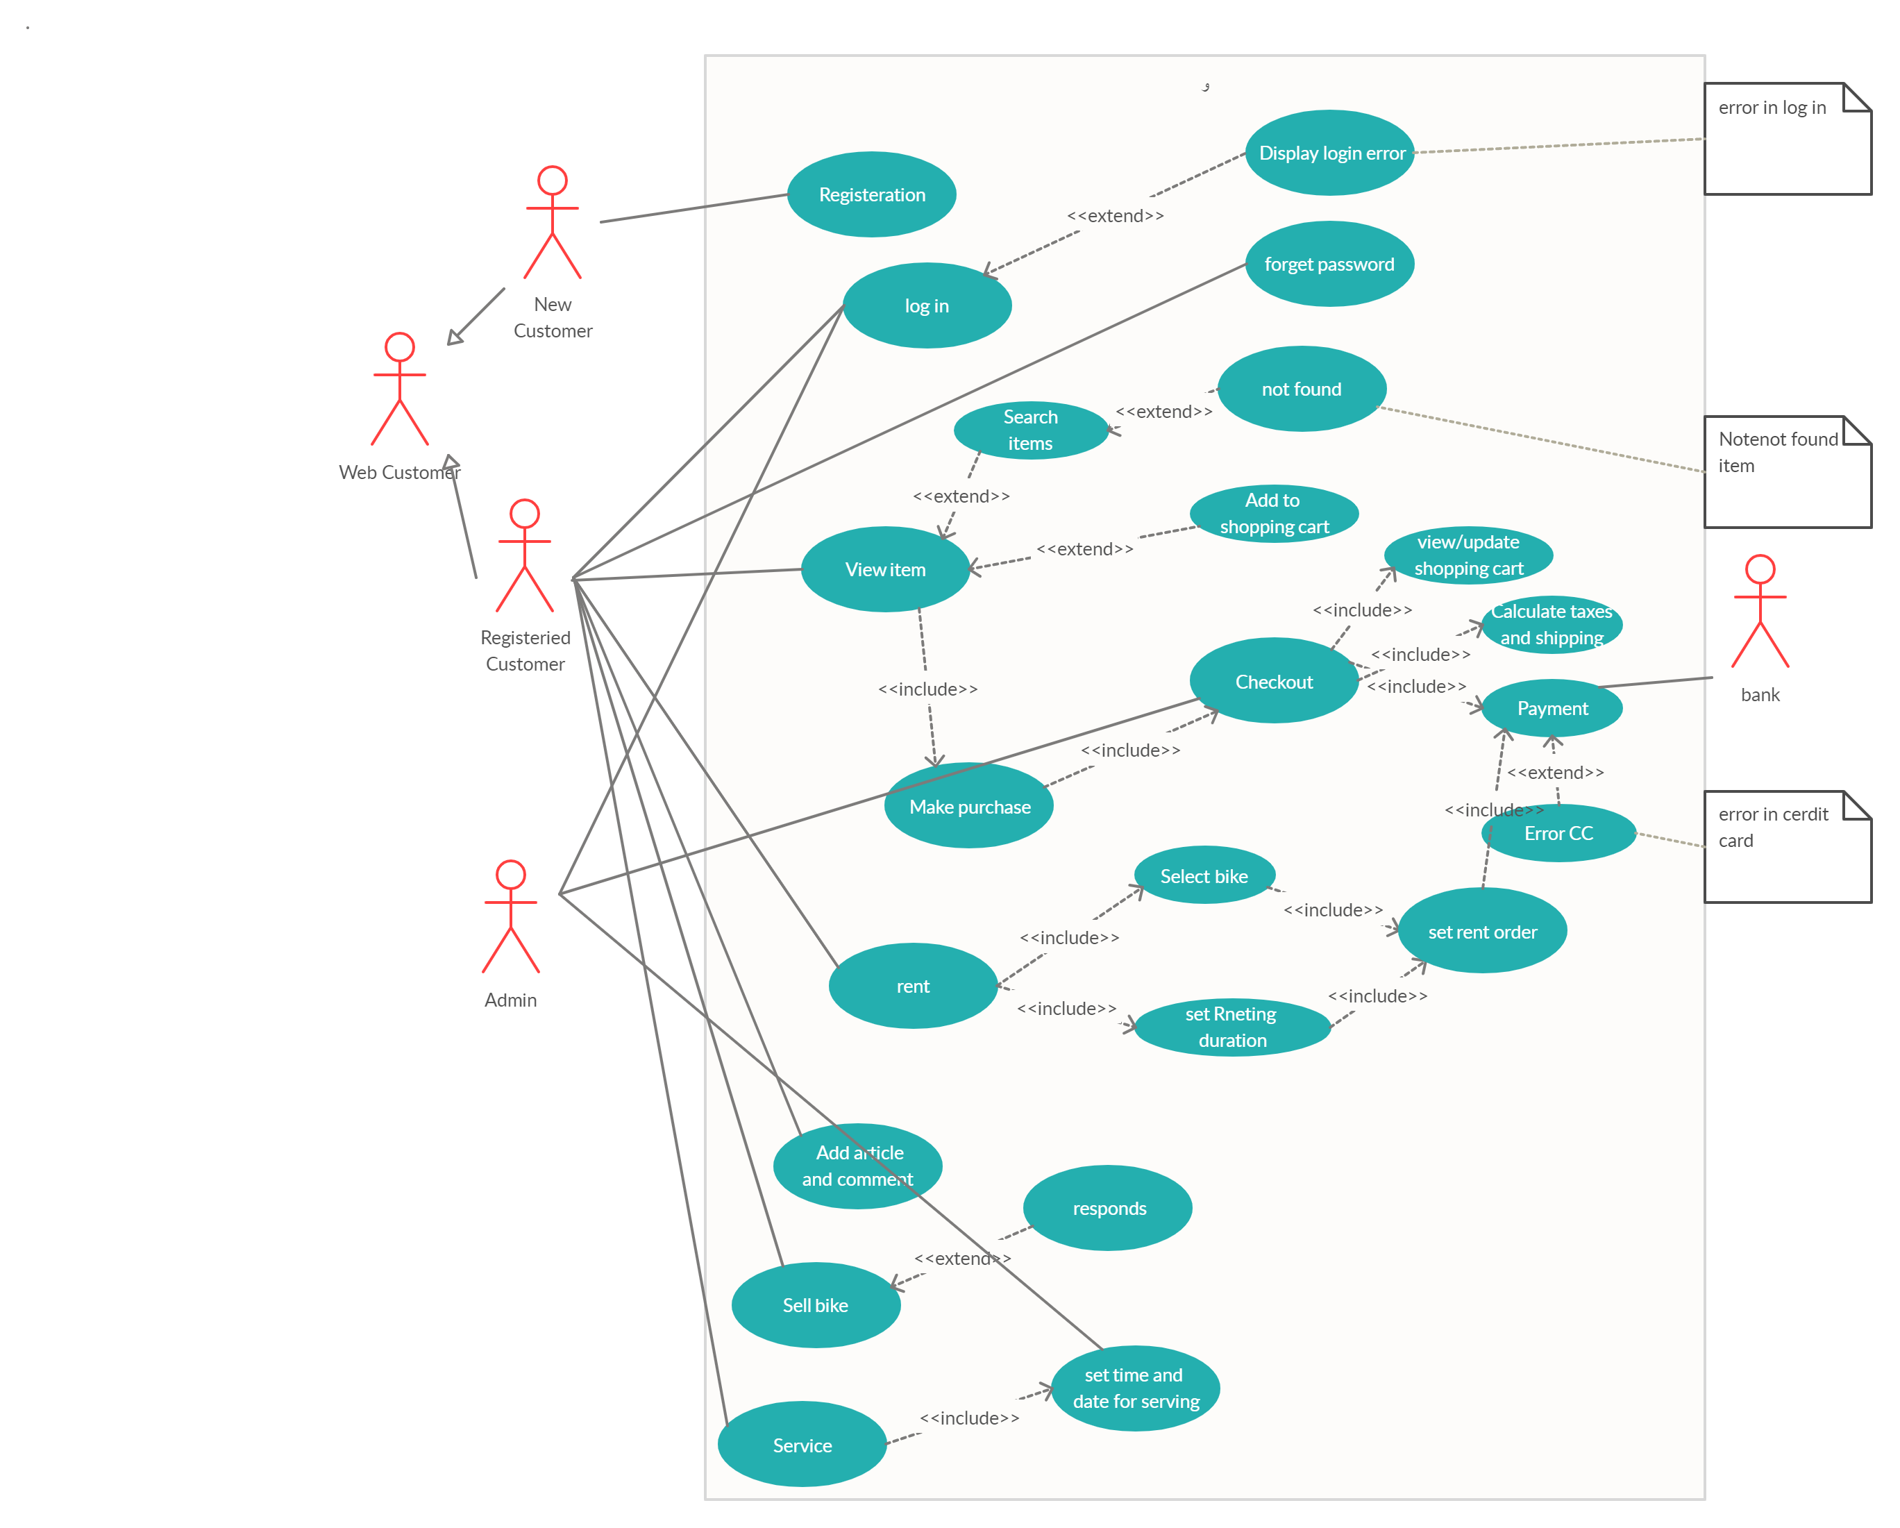

**b) Detailed Use Case Diagram**

UC1

|  |  |  |  |  |
| --- | --- | --- | --- | --- |
| Identifier and name | | | | UC1 Registration |
| Initiator | | New customer | | |
| Goal | | Registrants to system | | |
| Precondition | | None | | |
| Postcondition | | Unregistered customer become registered customer | | |
| Main success Scenario | | |  | |
| 1 | New customer inserts data   1. user name 2. first name 3. last name 4. phone number 5. password 6. confirm password 7. address 8. z-code   9-CC number | | | |
| 2 | System accept data | | | |
| 3 | User Registrated | | | |
| alternative |  | | | |
| 4 | System check data | | | |
| 5 | Data not valid | | | |
| 6 | Registration failed | | | |

|  |  |  |  |  |
| --- | --- | --- | --- | --- |
| Identifier and name | | | | UC2 Log in |
| Initiator | | registered customer, admin | | |
| Goal | | Log in to the system | | |
| Precondition | | User have to has a valid account | | |
| Postcondition | | The system display homepage | | |
| Main success Scenario | | |  | | |
| 1 | registered customer , admin enters user name | | | | |
| 2 | registered customer, admin enter password | | | | |
| 3 | System verify user name and password | | | | |
| 4 | customer logged in | | | | |
| extension |  | | | | |
| 3.1 | User name or password is wrong | | | | |
| 3.1a | Error message rise up | | | | |
| 3.2 | Customer re enter user name and password | | | | |

|  |  |  |  |  |
| --- | --- | --- | --- | --- |
| Identifier and name | | | | UC3 View item |
| Initiator | | Registered customer | | |
| Goal | | See item in store like bike, bike part | | |
| Precondition | | None | | |
| Postcondition | | Item viewed | | |
| Main success Scenario | | |  | | |
| 1 | Registered customer wants to view bike list | | | | |
| 2 | Bike list viewed | | | | |
| 3 | Registered customer wants to view bike part list | | | | |
| 4 | Bike parts list viewed | | | | |

|  |  |  |  |  |
| --- | --- | --- | --- | --- |
| Identifier and name | | | | UC4 search |
| Initiator | | Registered customer | | |
| Goal | | Search for specific item | | |
| Precondition | | Customer on web site | | |
| Postcondition | | Reach to his search | | |
| Main success Scenario | | |  | | |
| 1 | Customer click search button | | | | |
| 2 | Customer enter name for his search | | | | |
| 3 | System looks up for his search | | | | |
| 4 | Product found | | | | |
| alternative |  | | | | |
| 5 | Customer refines search result by added more specific | | | | |
| 6 | Step 2 and 3 re-executed | | | | |
| Extension |  | | | | |
| 3.1 | System don’t find product | | | | |
| 3.1a | Not found rise a message product not found | | | | |

|  |  |  |  |  |
| --- | --- | --- | --- | --- |
| Identifier and name | | | | UC5 Add to shopping cart |
| Initiator | | Registered customer | | |
| Goal | | Add item to shopping cart | | |
| Precondition | | Item must be searched or viewed | | |
| Postcondition | | Added to cart | | |
| Main success Scenario | | |  | | |
| 1 | customer search for item or view it | | | | |
| 2 | System found item | | | | |
| 3 | System view item | | | | |
| 4 | Customer add item to shopping cart | | | | |
| Unsuccessful  Scenario |  | | | | |
| 5 | System doesn’t find item | | | | |
| 6 | System refines specific search | | | | |
| 7 | Re-enter name again | | | | |

|  |  |  |  |  |
| --- | --- | --- | --- | --- |
| Identifier and name | | | | UC6 Make purchase |
| Initiator | | Registered customer | | |
| Goal | | Customer want to make purchase | | |
| Precondition | | 1. Registered customer 2. There is item in shopping cart | | |
| Postcondition | | Registered customer will go to Checkout | | |
| Main success Scenario | | |  | | |
| 1 | Registered customer added item to cart successful | | | | |
| 2 | Registered customer asked for purchase | | | | |
| 3 | System convert him to checkout | | | | |
| Unsuccessful  Scenario |  | | | | |
| 4 | No item in cart | | | | |
| 5 | Purchase failed | | | | |

|  |  |  |
| --- | --- | --- |
| Identifier and name | | UC7 forget Password |
| Initiator | Registered customer, System | |
| Goal | Registered customer forgets his password | |
| Precondition | He must forget his password | |
| Postcondition | Password sent | |

|  |  |  |
| --- | --- | --- |
| Main success Scenario | |  |
| 1 | Registered customer forgets his password | |
| 2 | System verify user identity | |
| 3 | Registered customer confirm identity | |
| 4 | System send to Registered customer password | |
| Unsuccessful  Scenario |  | |
| 3.1 | Customer cannot confirm identity | |
| 3.2 | System send another verifying method | |
| 3.3 | Customer cannot confirm another method | |
| 3.4 | System will not send password | |

|  |  |  |
| --- | --- | --- |
| Identifier and name | | UC8 Check out |
| Initiator | Registered customer, admin, system, bank | |
| Goal | Registered customer wants to make check out for his purchase | |
| Precondition | Registered customer wants to make purchase | |
| Postcondition | 1-System will show to Registered customer his shopping cart  2-admin will set tax and shipping   1. Registered customer use payment for pay 2. Purchase will done | |

|  |  |  |
| --- | --- | --- |
| Main success Scenario | |  |
| 1 | Registered customer wants to make checkout | |
| 2 | System will show Registered customer his purchases | |
| 3 | Registered customer confirm his purchases | |
| 4 | Admin will set taxes and shipping | |
| 5 | Registered customer use payment method, bank valid it | |
| 6 | Purchases done | |
| Unsuccessful  Scenario |  | |
| 5.1 | Bank Payment method not valid | |
| 5.2 | Purchase dismissed | |

|  |  |  |
| --- | --- | --- |
| Identifier and name | | UC9 Calculate tax and shipping |
| Initiator | Admin | |
| Goal | Calculate shipping and taxes | |
| Precondition | Customer want to checkout | |
| Postcondition | Taxes and shipping will be Calculate | |

|  |  |  |
| --- | --- | --- |
| Main success Scenario | |  |
| 1 | Registered customer want to make checkout | |
| 2 | Admin set taxes and shipping money | |

|  |  |  |
| --- | --- | --- |
| Identifier and name | | UC10 View/update shopping cart |
| Initiator | System, Registered customer | |
| Goal | View/update shopping cart | |
| Precondition | Item added to shopping cart  Registered customer want to make purchase | |
| Postcondition | View or update shipping cart | |

|  |  |  |
| --- | --- | --- |
| Main success Scenario | |  |
| 1 | Registered customer add item to shopping cart | |
| 2 | Registered customer wants to make purchase | |
| 3 | System view shopping cart | |
| 4 | Registered customer want to add / delete item from shopping cart | |
| 5 | System update shopping cart | |

|  |  |  |
| --- | --- | --- |
| Identifier and name | | UC11 Payment |
| Initiator | Registered customer, bank | |
| Goal | Registered customer wants to pay for his purchase | |
| Precondition | Registered customer wants to checkout | |
| Postcondition | Payment done successfully | |

|  |  |  |
| --- | --- | --- |
| Main success Scenario | |  |
| 1 | Registered customer wants to Checkout | |
| 2 | Registered customer select online payment | |
| 3 | Registered customer enter CC number | |
| 4 | Registered customer enter CVV | |
| 5 | Registered customer enters EXP date | |
| 6 | Bank verify Data od CC | |
| 7 | Bank verified Data | |
| 8 | Payment Done | |
| Extension |  | |
| 7.1 | Bank said data not verified | |
| 7.3 | Payment does not complete | |

|  |  |  |
| --- | --- | --- |
| Identifier and name | | UC12 rent |
| Initiator | Registered customer, system | |
| Goal | Registered customer want to rent a bike | |
| Precondition | None | |
| Postcondition | Bike is rented | |

|  |  |  |
| --- | --- | --- |
| Main success Scenario | |  |
| 1 | System view bike for renting | |
| 2 | Registered customer select bike | |
| 3 | System request duraton | |
| 4 | Registered customer determine duration for renting | |
| 6 | Registered customer set order | |
| 7 | Registered customer pay for order | |
| 8 | System reserve bike for Registered customer | |

|  |  |  |
| --- | --- | --- |
| Identifier and name | | UC13 Set renting Duration |
| Initiator | Registered customer | |
| Goal | Determine renting duration | |
| Precondition | Registered customer wants to rent bike | |
| Postcondition | Registered customer set order | |

|  |  |  |
| --- | --- | --- |
| Main success Scenario | |  |
| 1 | Registered customer want to rent bike | |
| 2 | Registered customer select renting Duration | |

|  |  |  |
| --- | --- | --- |
| Identifier and name | | UC14 Set rent order |
| Initiator | Registered customer | |
| Goal | Set order to rent bike | |
| Precondition | Select bike and duration for renting must be selected | |
| Postcondition | Registered customer pay for his order | |

|  |  |  |
| --- | --- | --- |
| Main success Scenario | |  |
| 1 | Registered customer Select bike | |
| 2 | Registered customer Determine rent duration | |
| 3 | Registered customer Set order | |

|  |  |  |
| --- | --- | --- |
| Identifier and name | | UC15 Select bike |
| Initiator | Registered customer, System | |
| Goal | Registered customer select bike from renting bike list | |
| Precondition | Registered customer want to rent bike | |
| Postcondition | Bike selected | |

|  |  |  |
| --- | --- | --- |
| Main success Scenario | |  |
| 1 | Registered customer want to rent bike | |
| 2 | System offers renting bikes list | |
| 3 | Registered customer choose bike | |

|  |  |  |
| --- | --- | --- |
| Identifier and name | | UC16 Add article and comment |
| Initiator | Registered customer | |
| Goal | Add article and comment in blog section | |
| Precondition | None | |
| Postcondition | Added successfully | |

|  |  |  |
| --- | --- | --- |
| Main success Scenario | |  |
| 1 | Registered customer write article | |
| 2 | Registered customer posts the article | |
| 3 | Another Registered customer comment on the post | |

|  |  |  |
| --- | --- | --- |
| Identifier and name | | UC17 Sell bike |
| Initiator | Registered customer | |
| Goal | Want to sell his bike | |
| Precondition | None | |
| Postcondition | Registered customer post to sell his bike and receive response | |

|  |  |  |
| --- | --- | --- |
| Main success Scenario | |  |
| 1 | Registered customer but his bike photo to sell it | |
| 2 | Registered customer wait for responds | |

|  |  |  |
| --- | --- | --- |
| Identifier and name | | UC18 responds |
| Initiator | Registered customer | |
| Goal | Registered customer responds to buy bike from another Registered customer who post it for sold | |
| Precondition | None | |
| Postcondition | His responds is done | |

|  |  |  |
| --- | --- | --- |
| Main success Scenario | |  |
| 1 | Registered customer sent responds on another Registered customer | |
| 2 | Responds will be sent to the another Registered customer | |

|  |  |  |
| --- | --- | --- |
| Identifier and name | | UC19 Service |
| Initiator | Registered customer | |
| Goal | Registered customer request service | |
| Precondition | None | |
| Postcondition | Registered customer set data and time for serving | |

|  |  |  |
| --- | --- | --- |
| Main success Scenario | |  |
| 1 | Registered customer want to make service for his bike | |
| 2 | Registered customer set information about bike | |
| 3 | Registered customer set information about kind of service | |

|  |  |  |
| --- | --- | --- |
| Identifier and name | | UC20 Set time and date for serving |
| Initiator | Registered customer, admin | |
| Goal | Registered customer set data and time and admin confirm it | |
| Precondition | Request service | |
| Postcondition | Service is been scheduled | |

|  |  |  |
| --- | --- | --- |
| Main success Scenario | |  |
| 1 | Registered customer set time and date | |
| 2 | Admin receive date and time | |
| 3 | Admin schedule serving time | |
| 4 | Service scheduled | |

**c) Package Diagram**

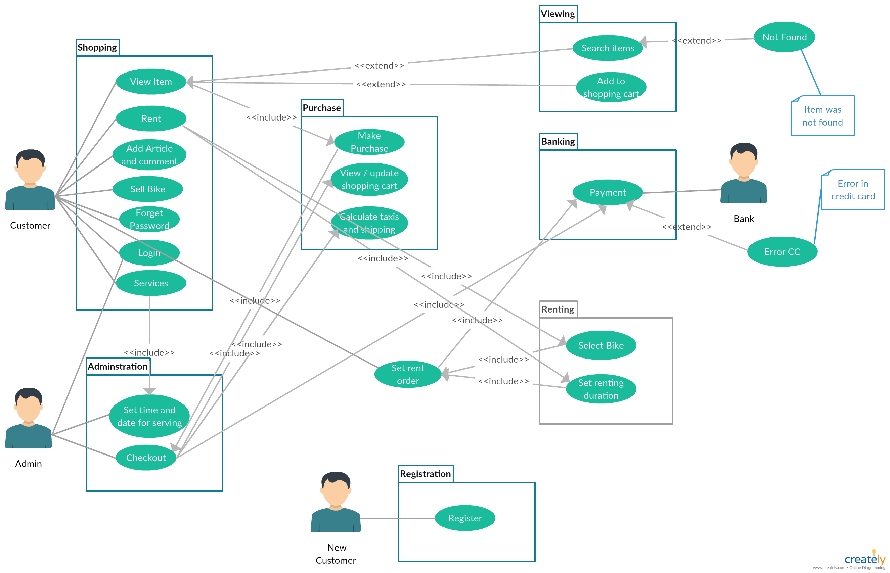

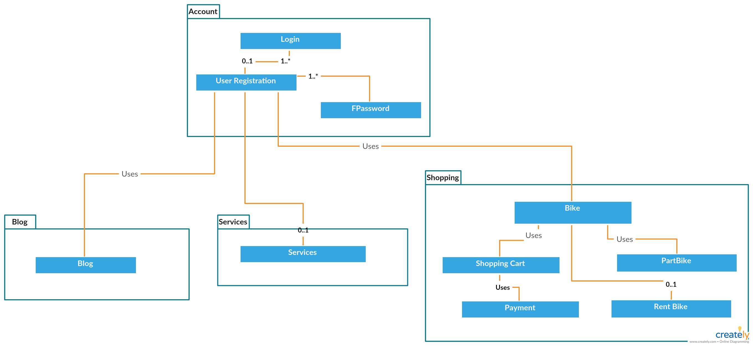

11)Structural & Behavioral Diagrams:

a) System Architecture

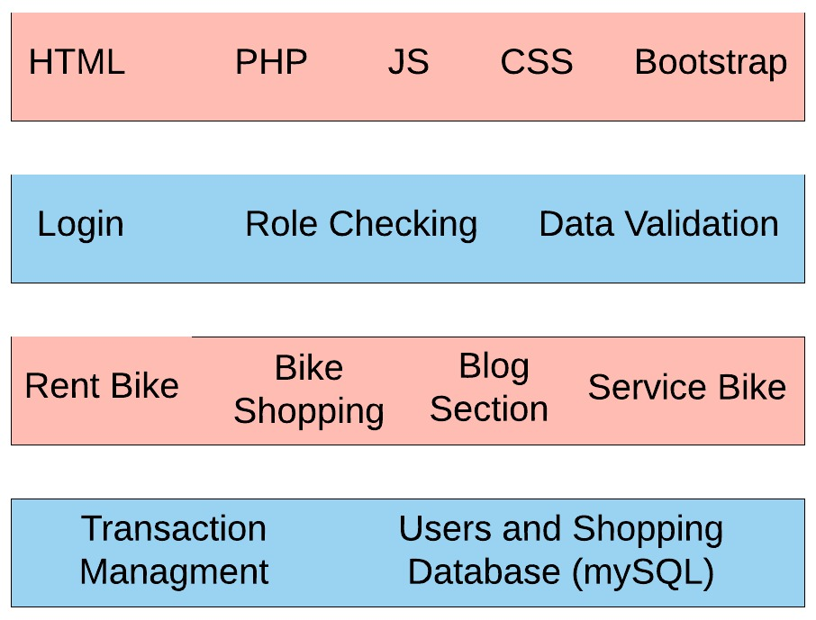

**b) Activity Diagram**

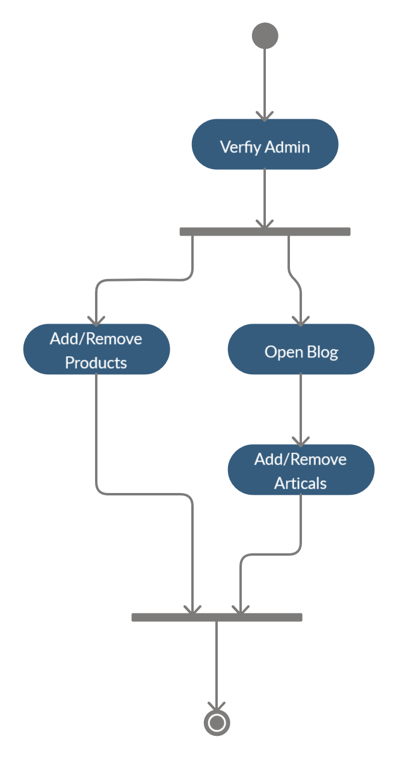

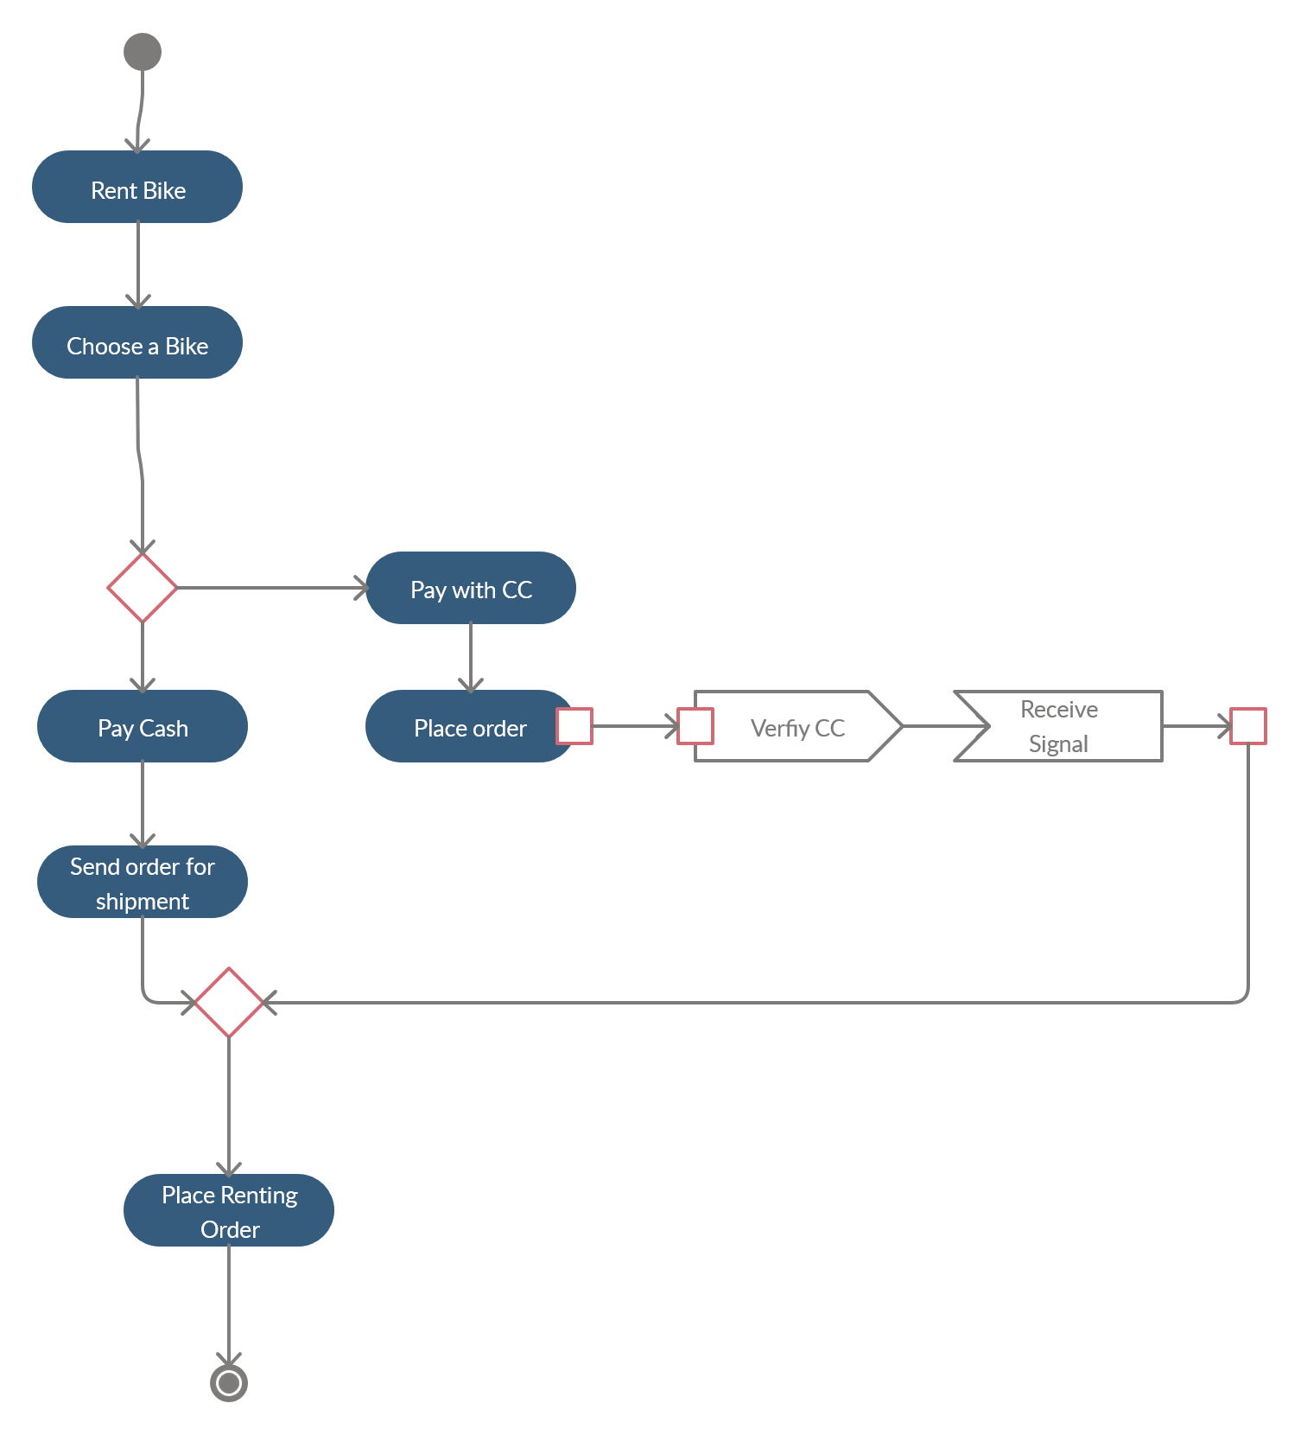

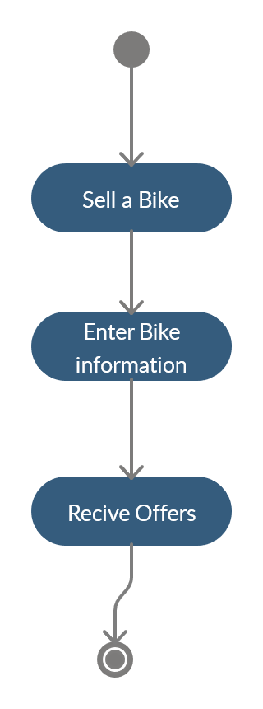

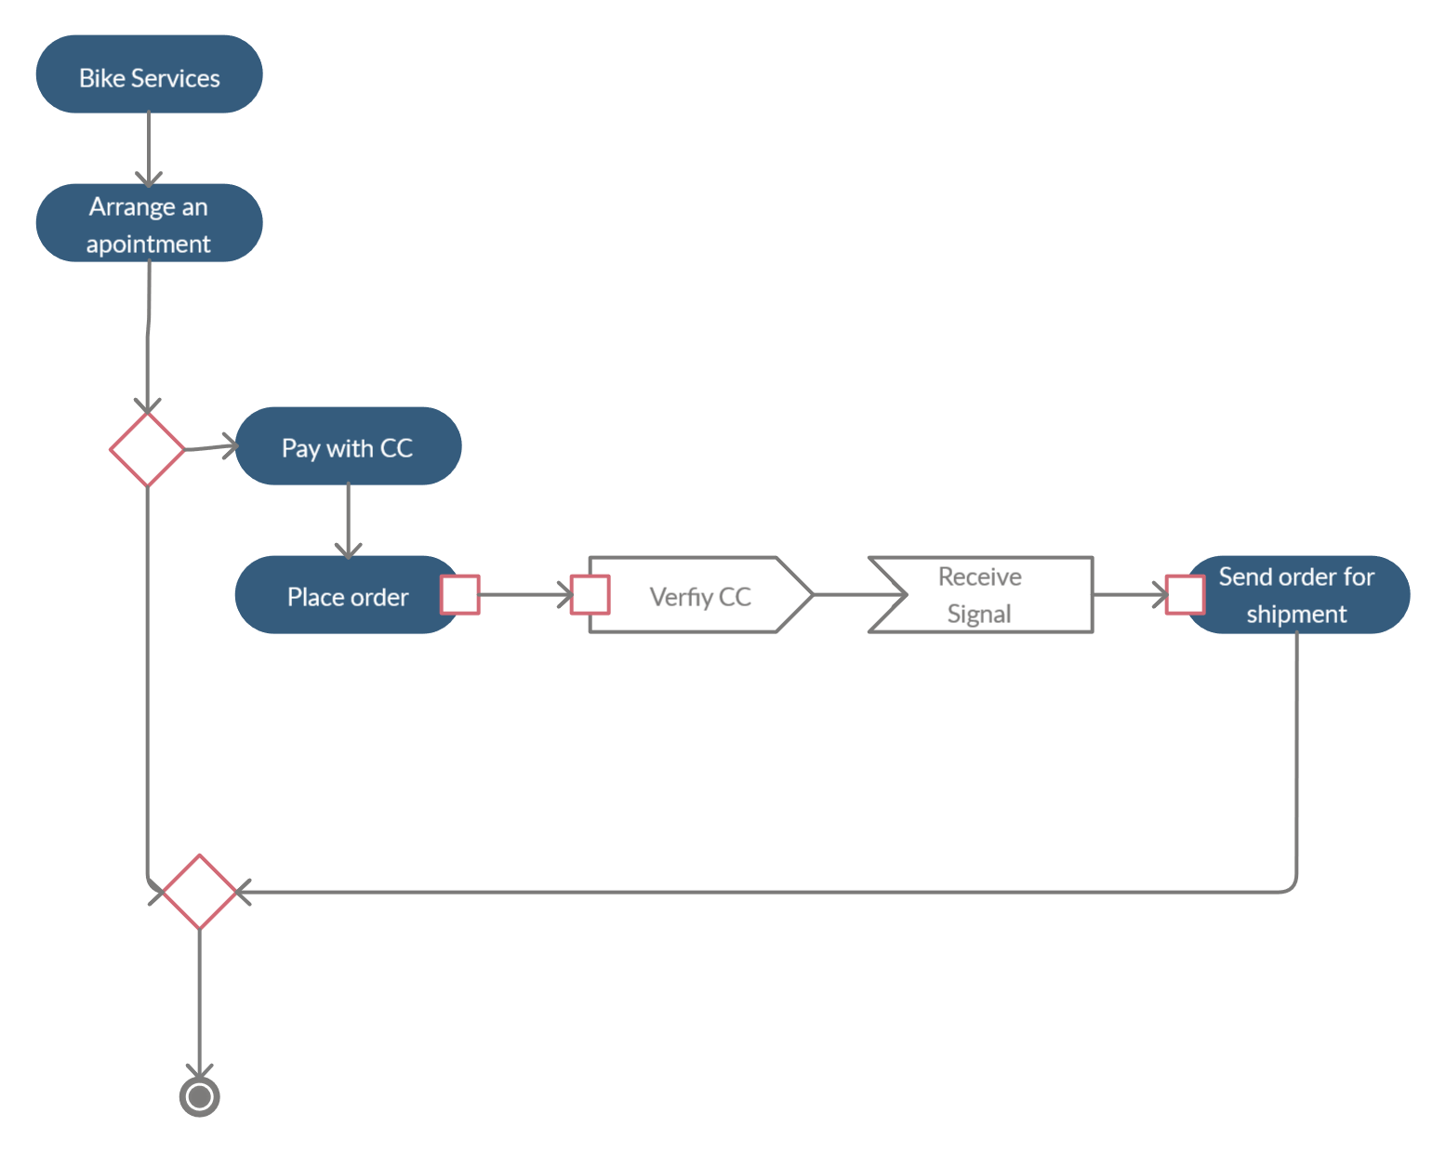

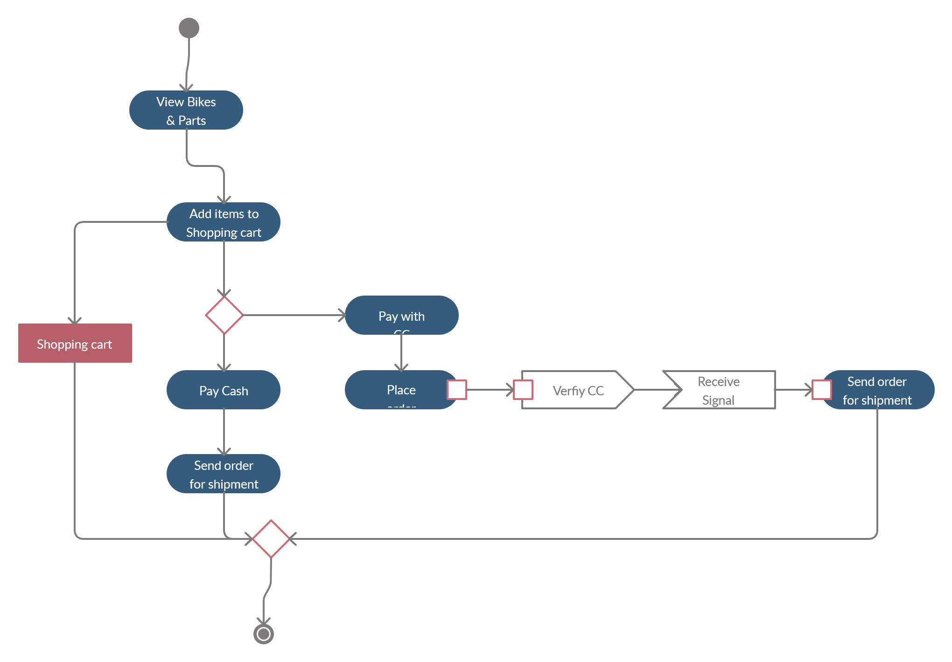

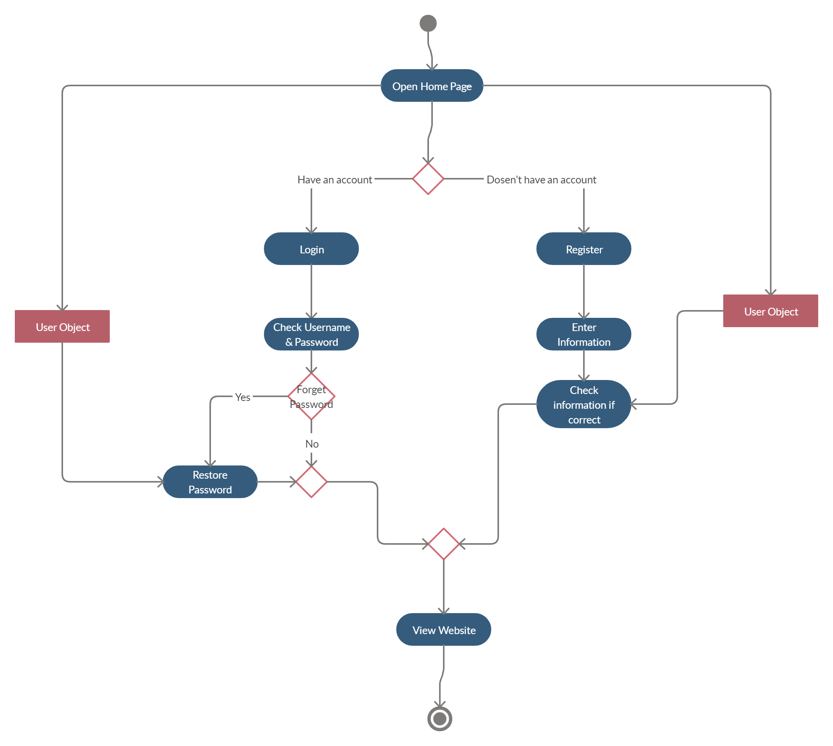

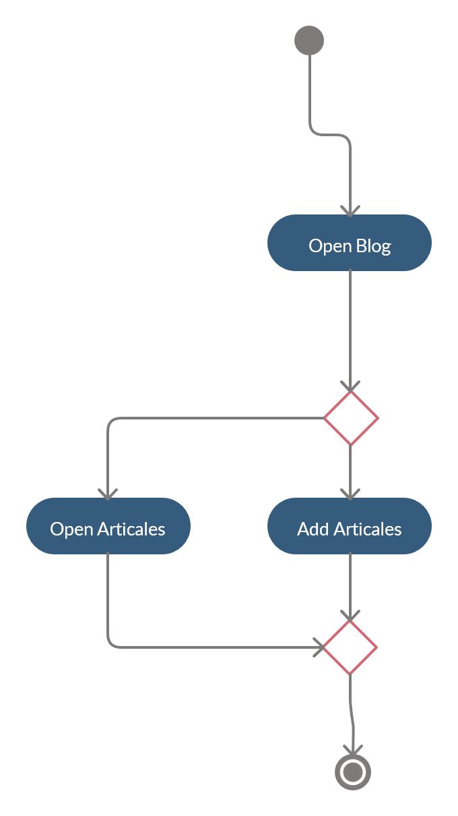

**c)List of Interfaces required:**

|  |  |
| --- | --- |
| User | Interface |
| New & Registered Users, Admins | 1-Login & Registration Page |
| Registered Users | 2-Forgot password Page |
| Registered Users, Admins | 3-Bike Renting Page |
| Registered Users, Admins | 4-Bike Cart Page |
| Registered Users, Admins | 5-Blog Page |
| Registered Users, Admins | 6-Bike Parts Page |
| Any Visitors | 7-About us Page |
| Registered Users | 8-Bike Page |

**d)Software Analysis Pattern**

* What is a Software Analysis Pattern?

It is a step in the overall software lifecycle. This step comes after the requirements step. It establishes an ideal solution to the problem that defined by the Use Case Models. They are patterns which capture conceptual models in an application domain in order to allow reuse across applications. There are over 50 Analysis patterns. They:

1-Speeds up the process of moving from a concrete problem to

an abstract model.

2- facilitates the transformation of the analysis model into the

design model.

-There are many types of Software Analysis Patterns like Party, Accountability, Organization Hierarchies, Quantity and etc.

So we will choose one of the patterns, define it and apply it according to our website.

|  |  |
| --- | --- |
| Pattern Name | Party |
| Intent | The intent of the Party pattern applies when a person is responsible to another. By applying the party pattern, it can ease up the complexity of an organization structure model. |
| Motivation | When a newly website getting more and more users, the website will have internal Admin information, external like user information etc. Each of those has addresses, phone numbers, email address or other contact information. |
| Solution | we will Define a party as the super type of all entities. Party is used to define countless models. |

Person

(Admins and Users)

Website System

Telephone Number

Party

Address

E-mail Address

Username

Password

**e) Class Diagram 1:**

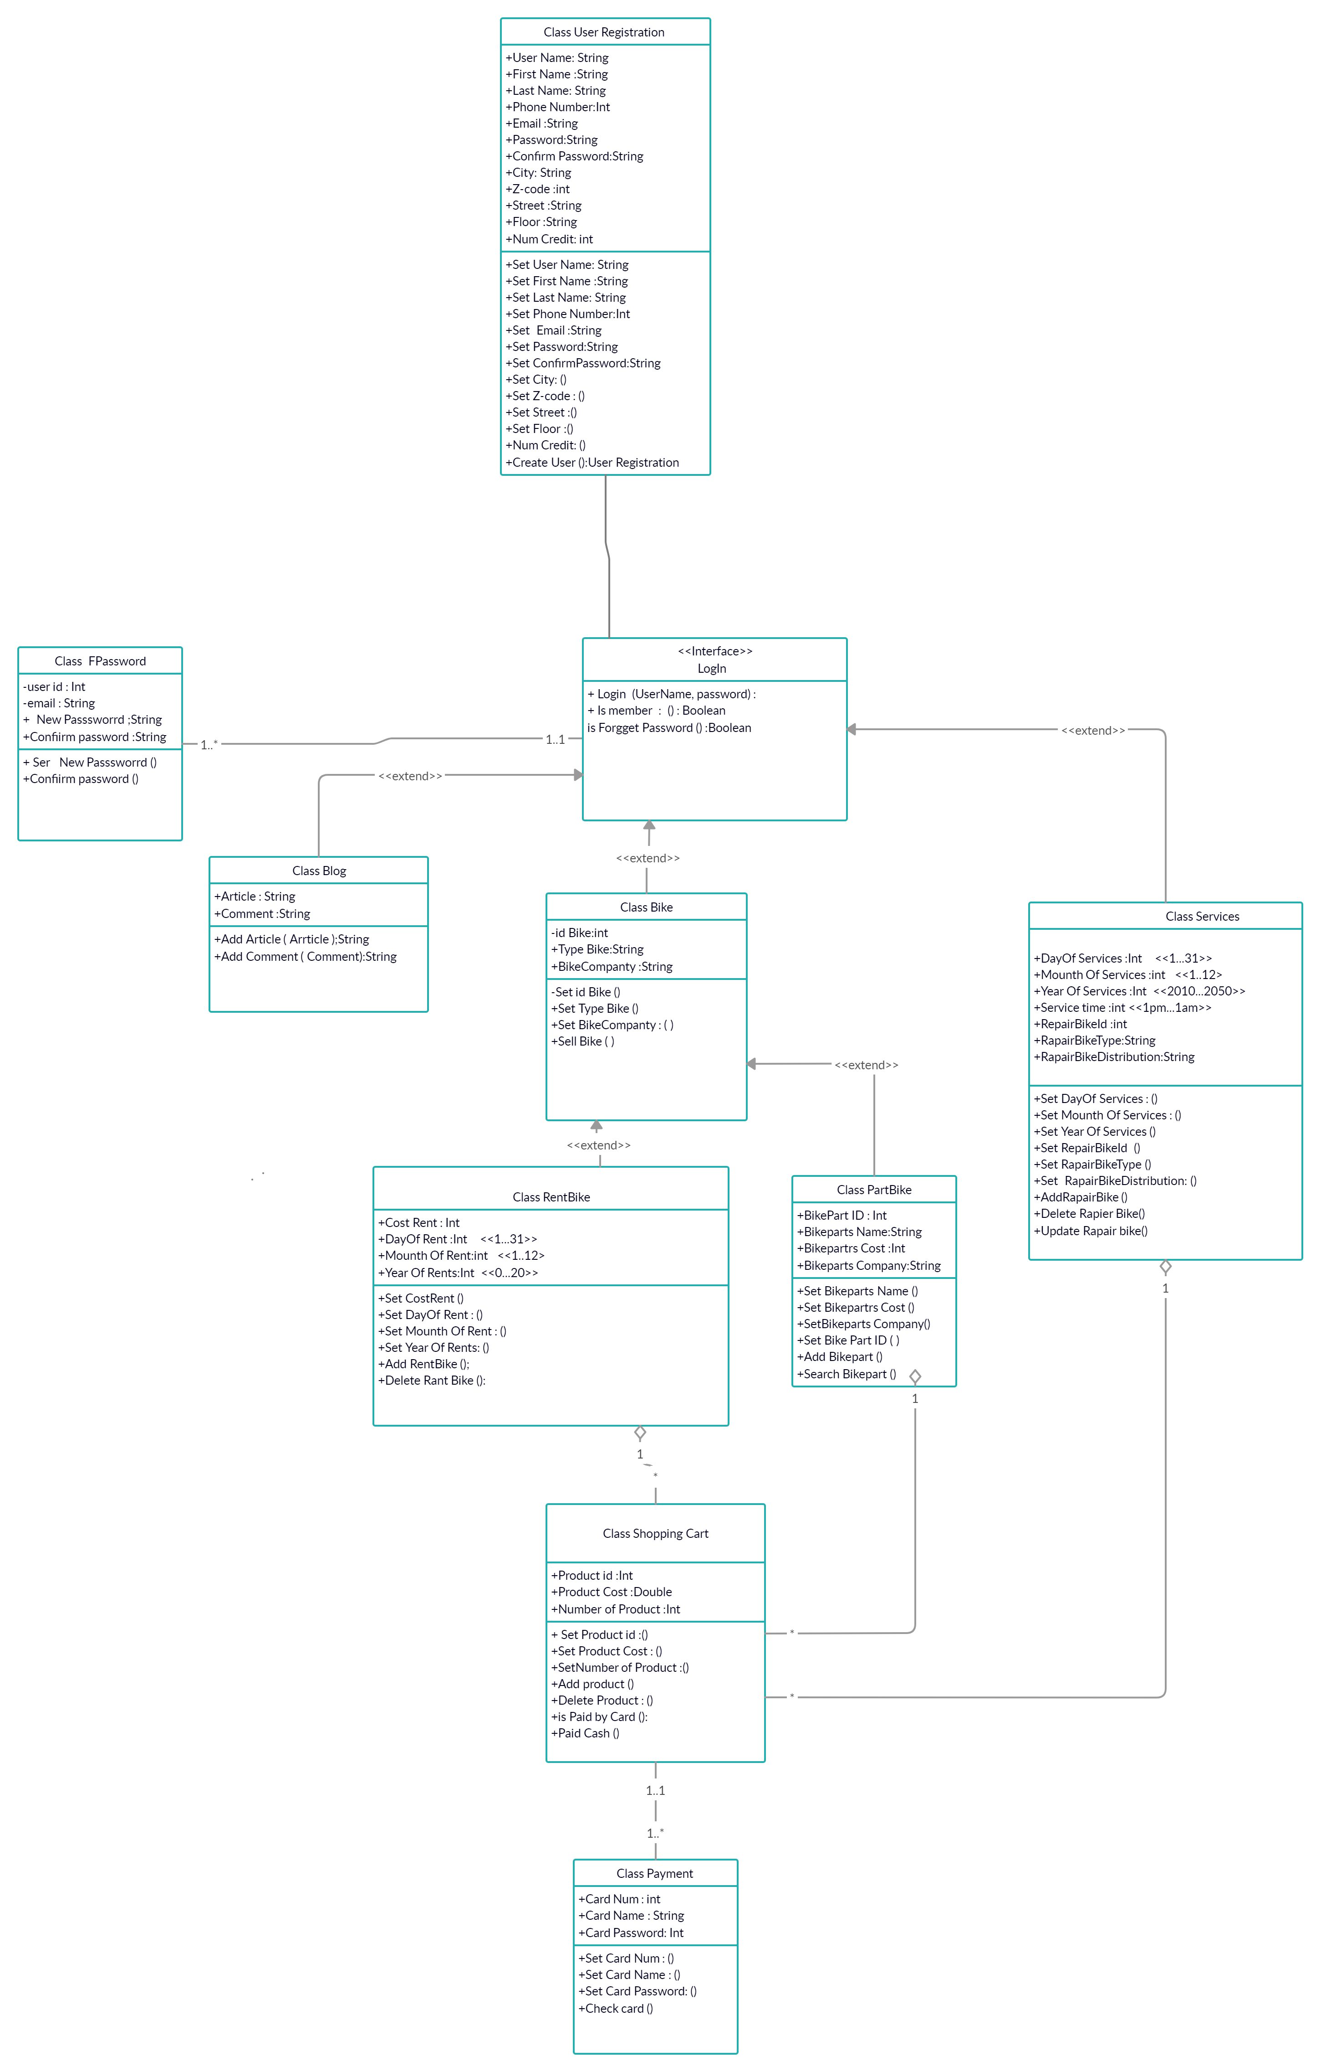

**F) Sequence Diagram**

Registration UC 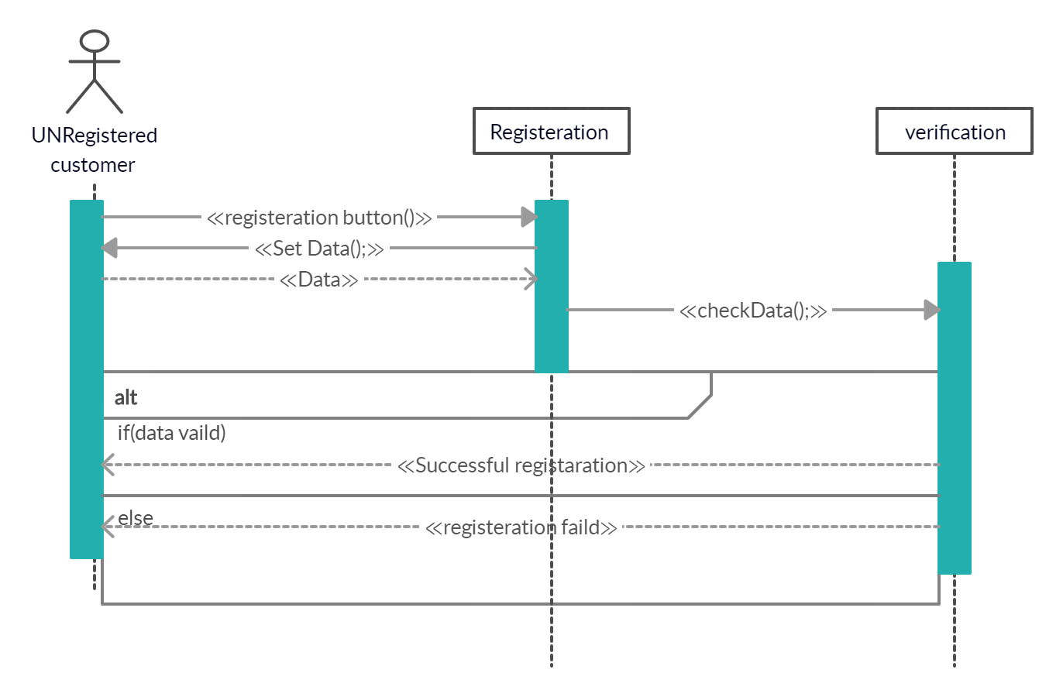

Login UC 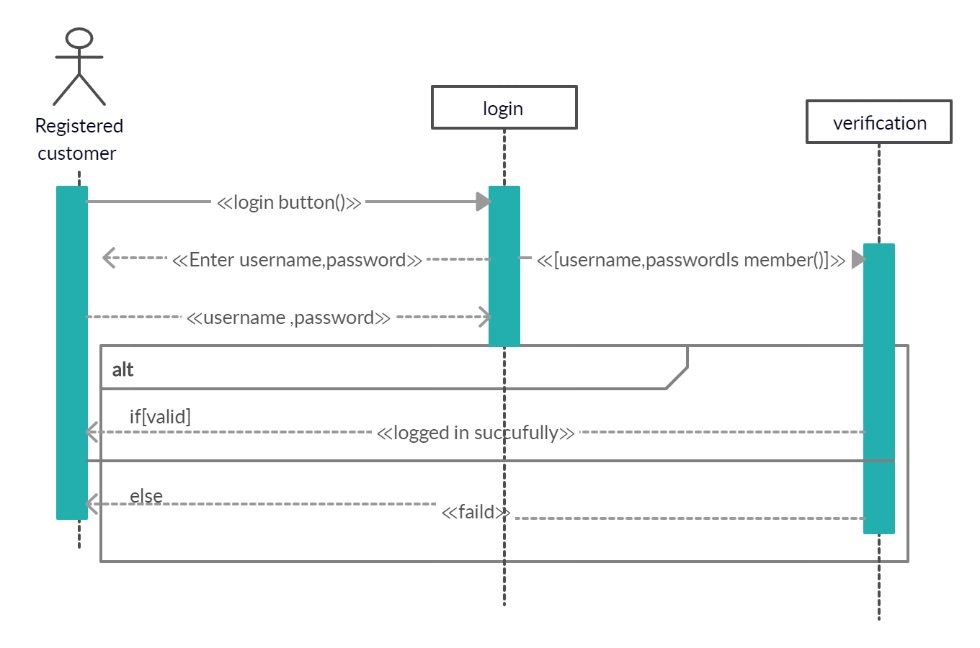

View item UC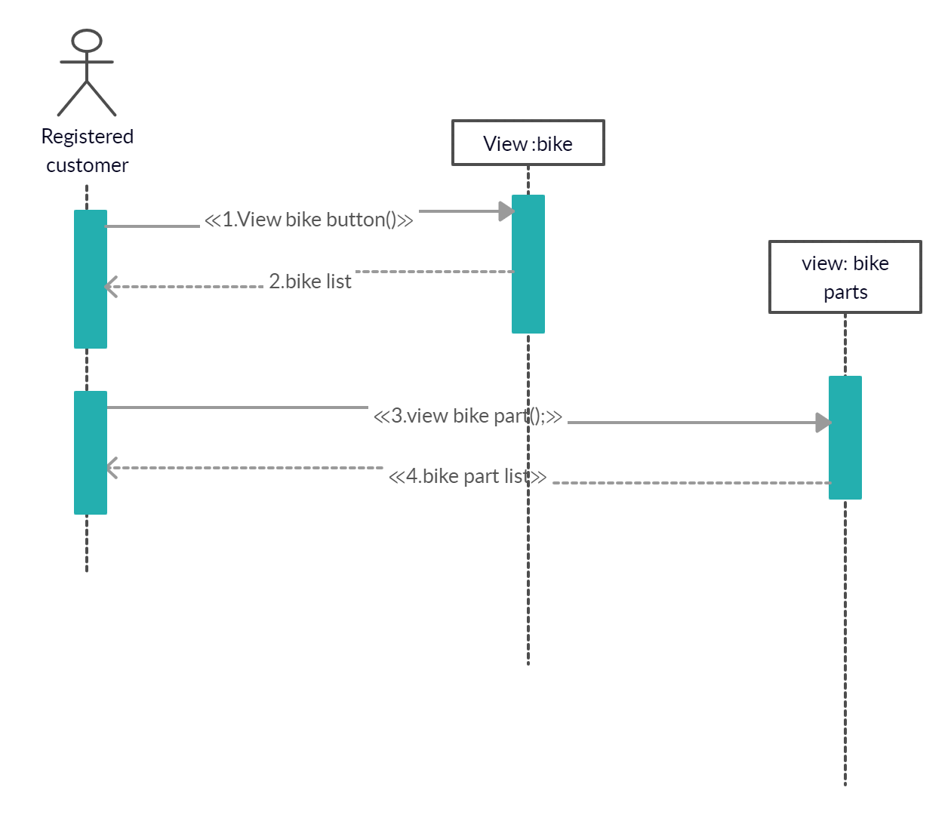

Search UC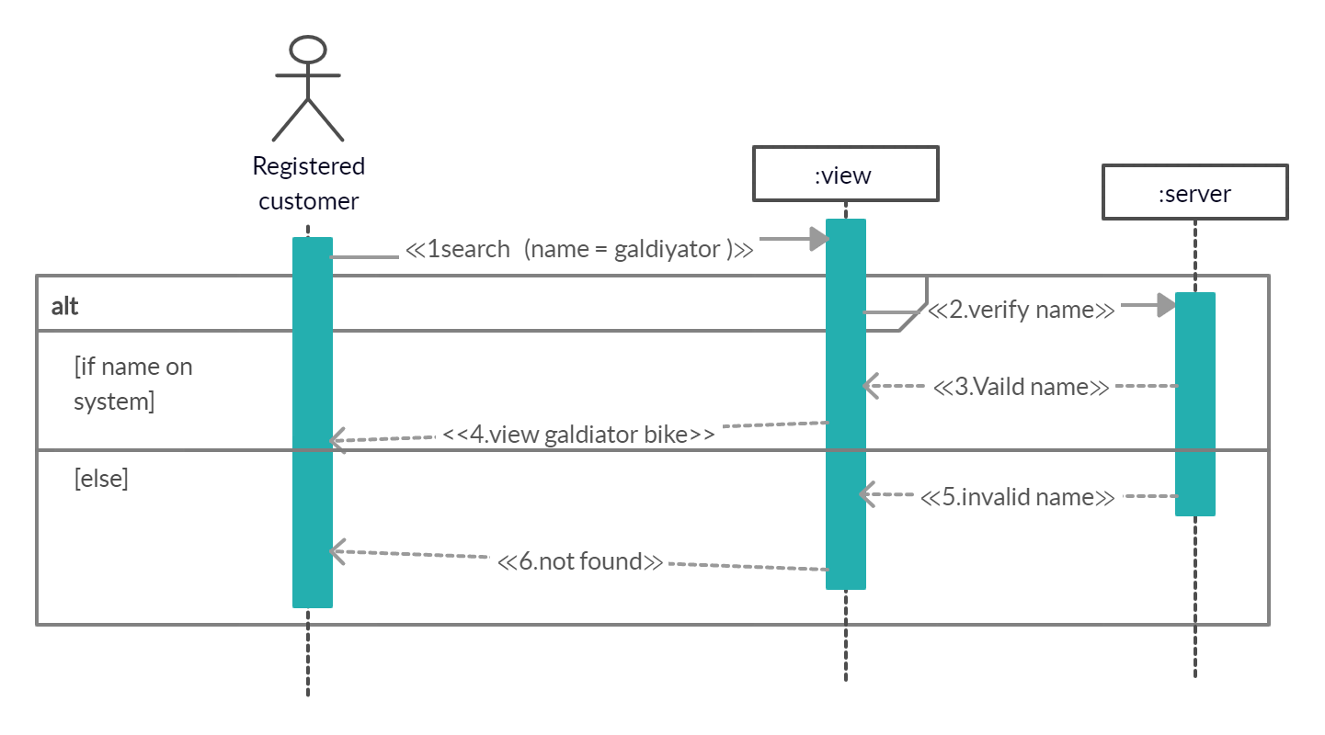

Add to shopping cart UC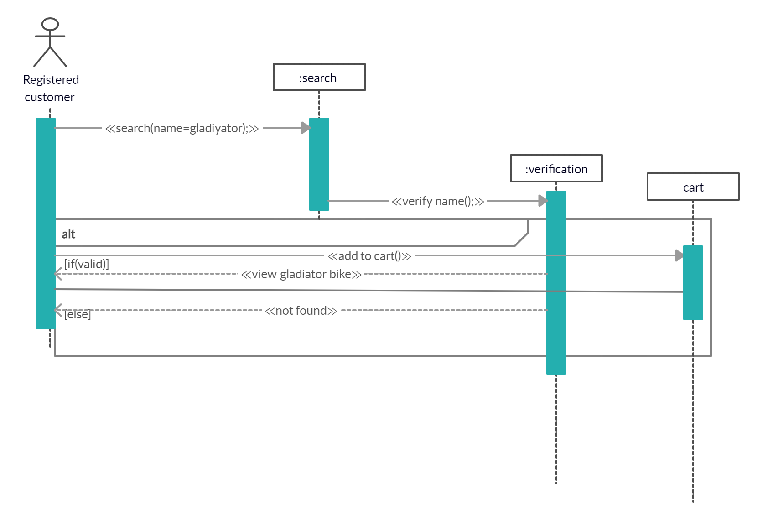

Make purchase UC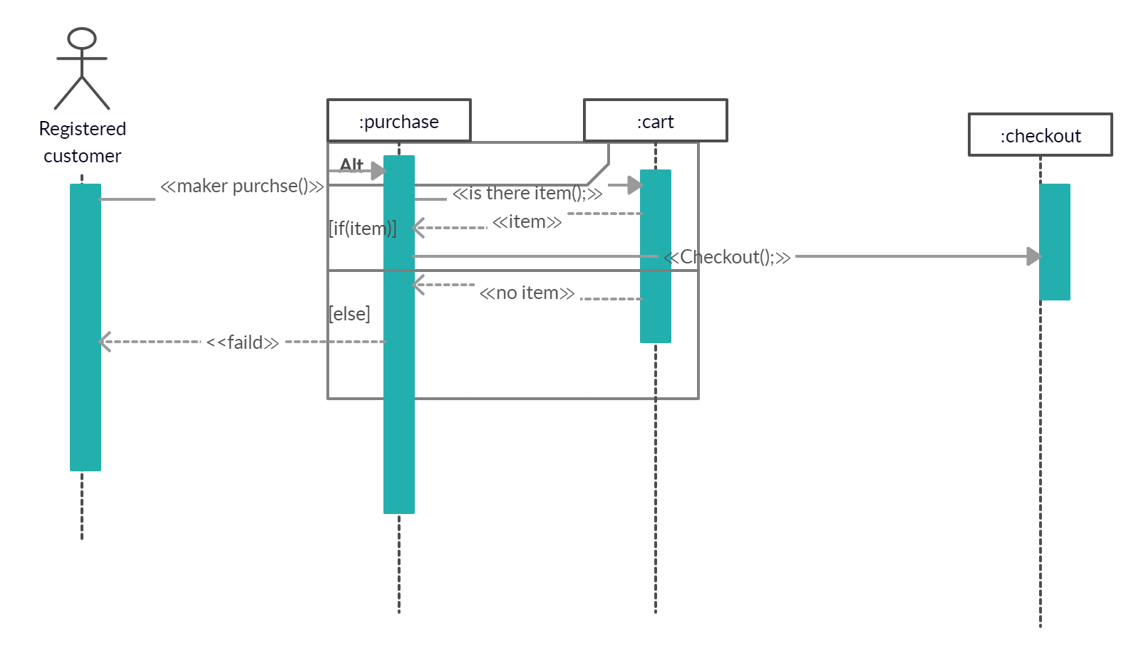

Forget password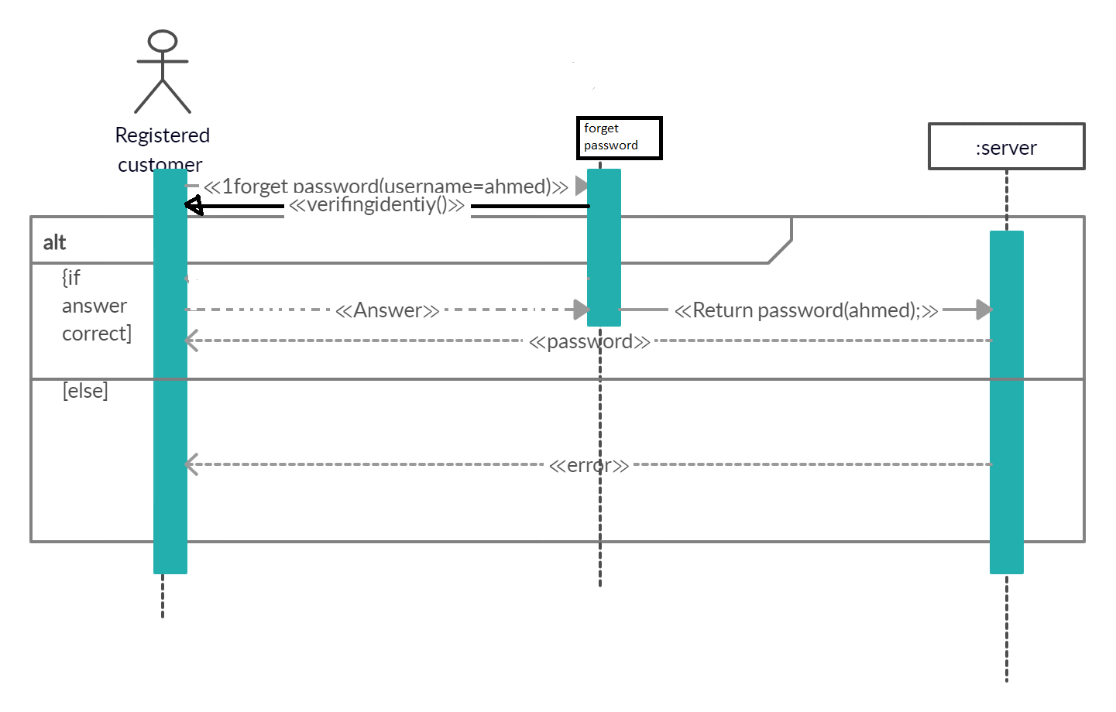

Checkout Uc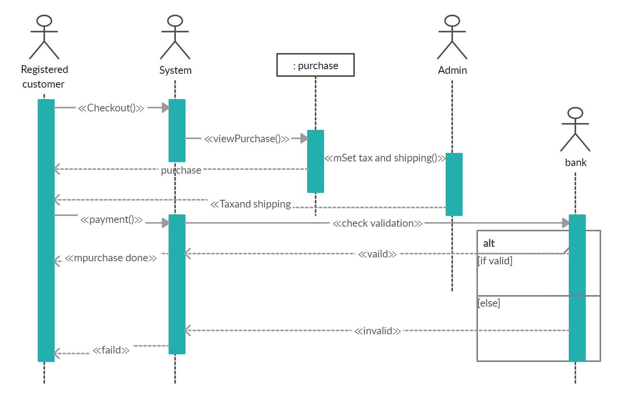

Calculate tax UC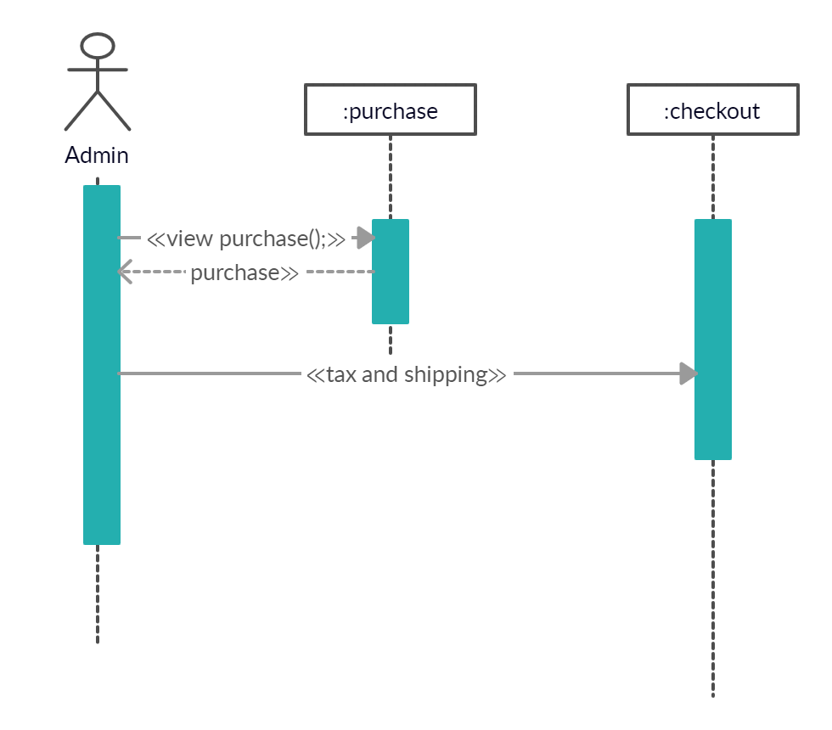

View/update shopping cart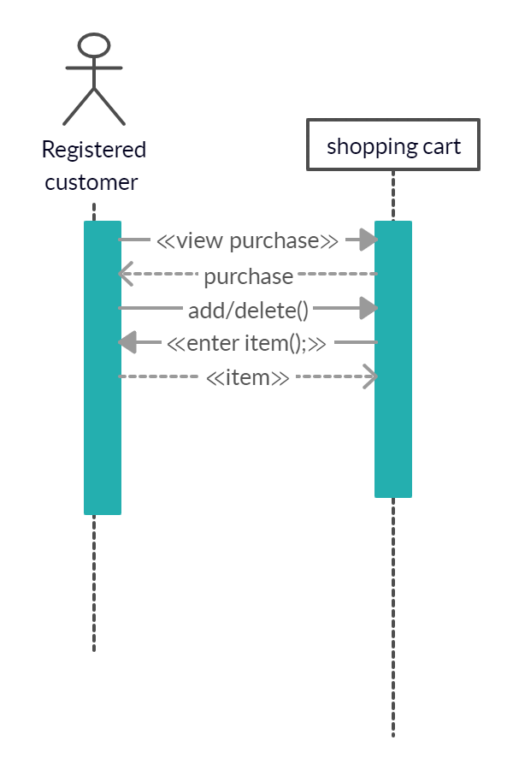

Payment 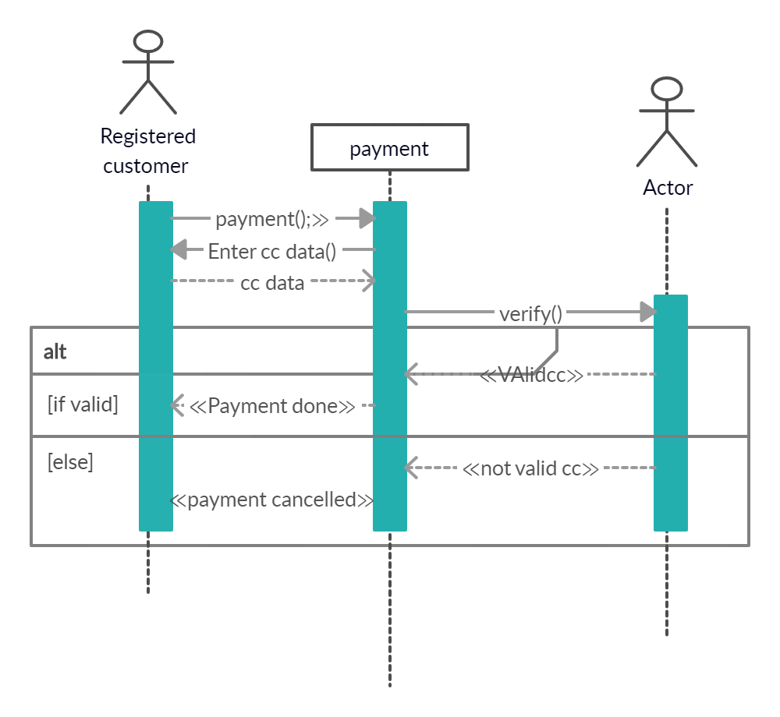

Rent uc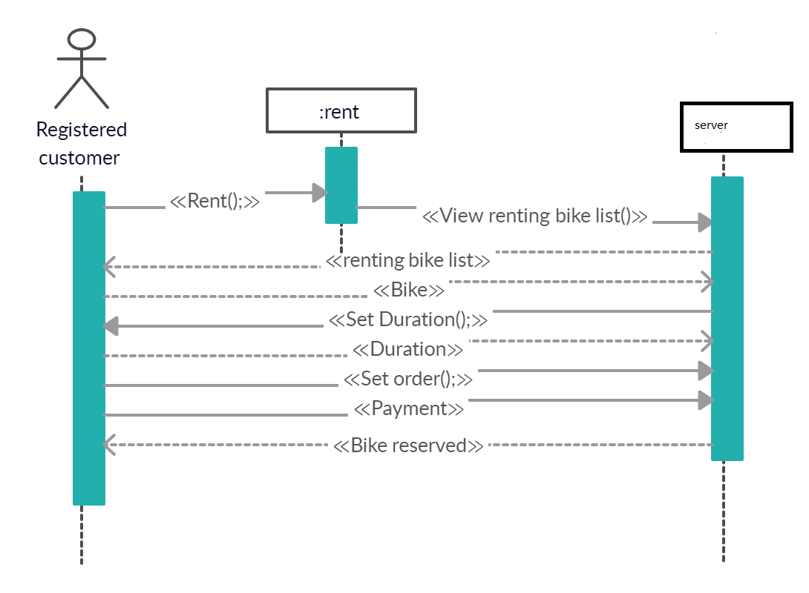

Select bike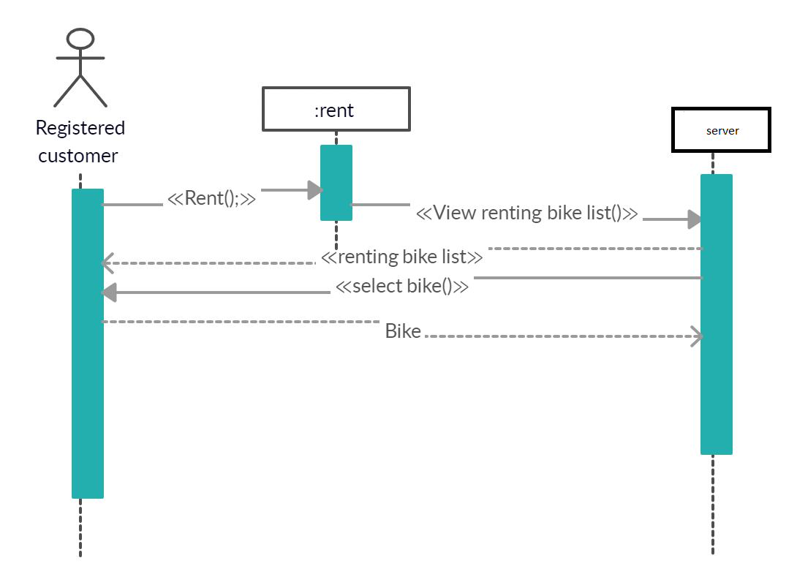

Add Article UC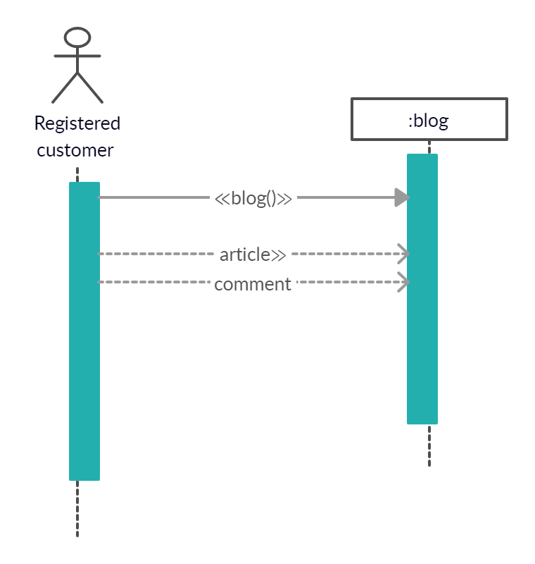

Responds UC 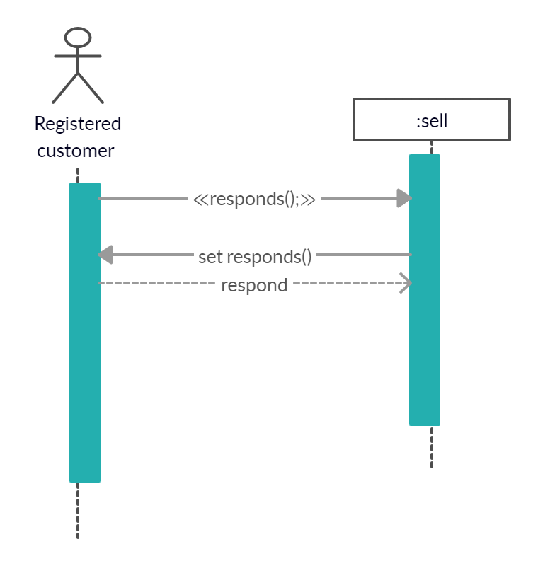

Sell UC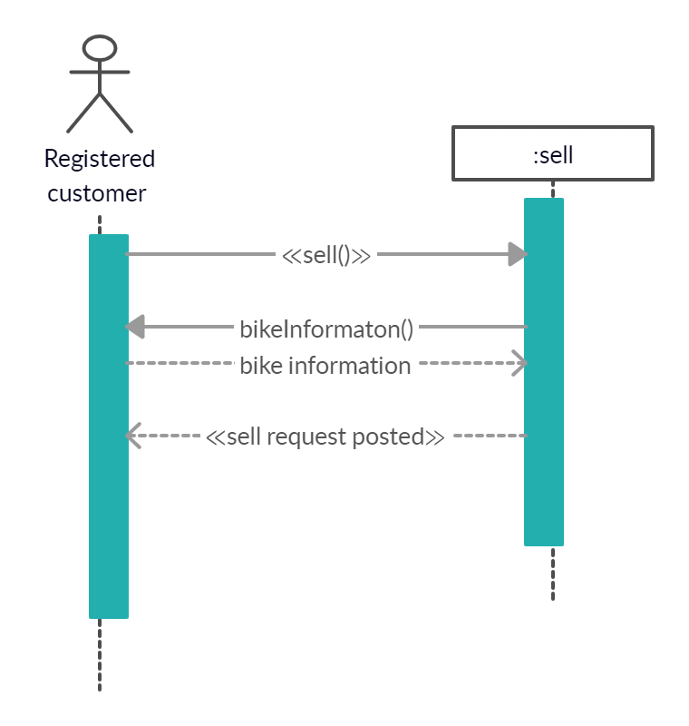

Service UC 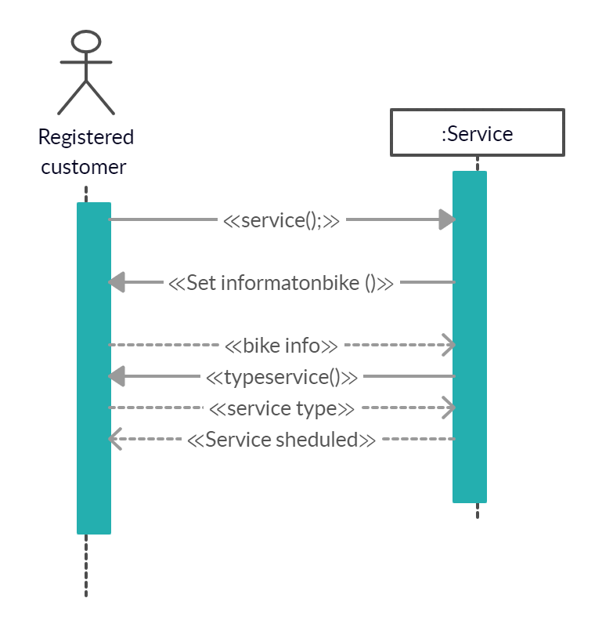

Set time and Date UC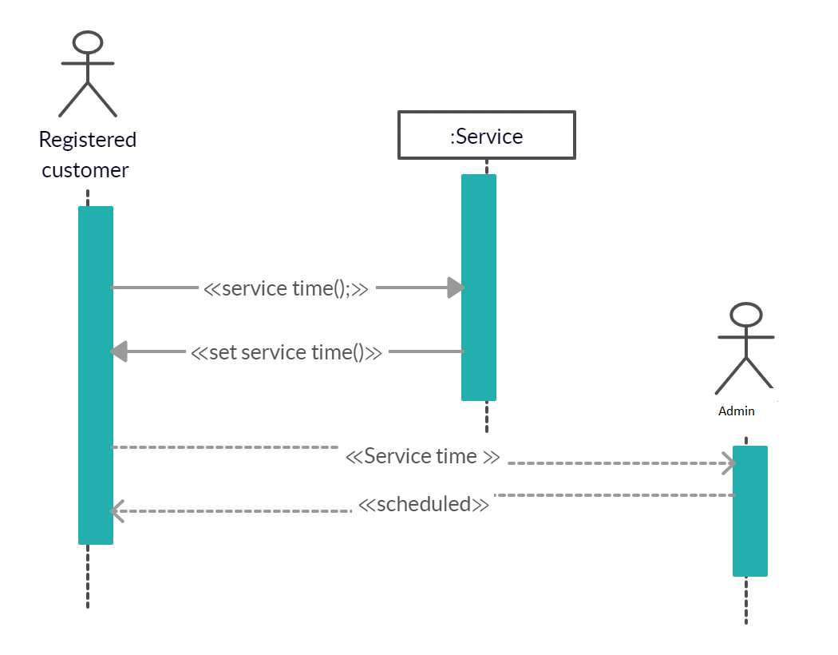

View/update shopping cart

G) System Sequence diagrams(SSDs)

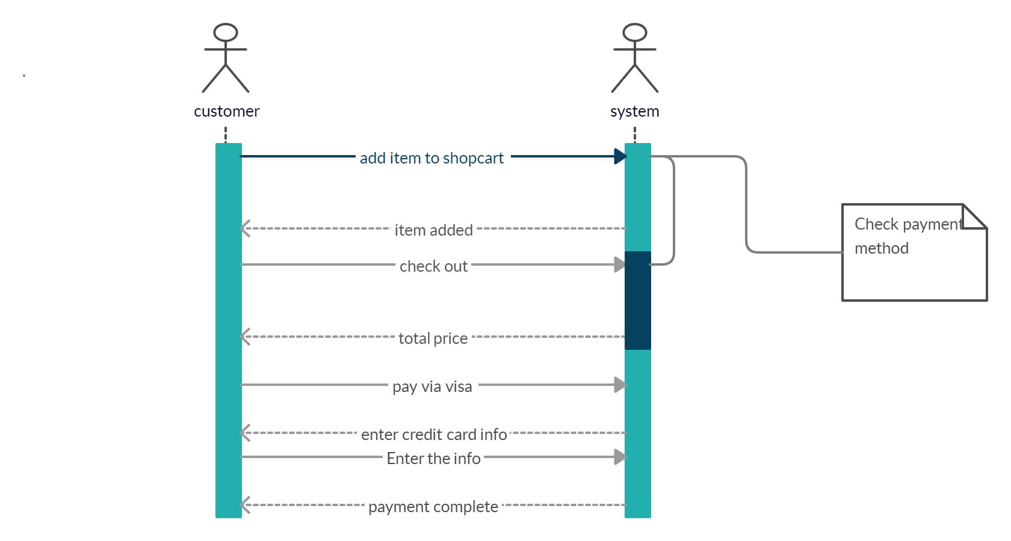Shopping

Registration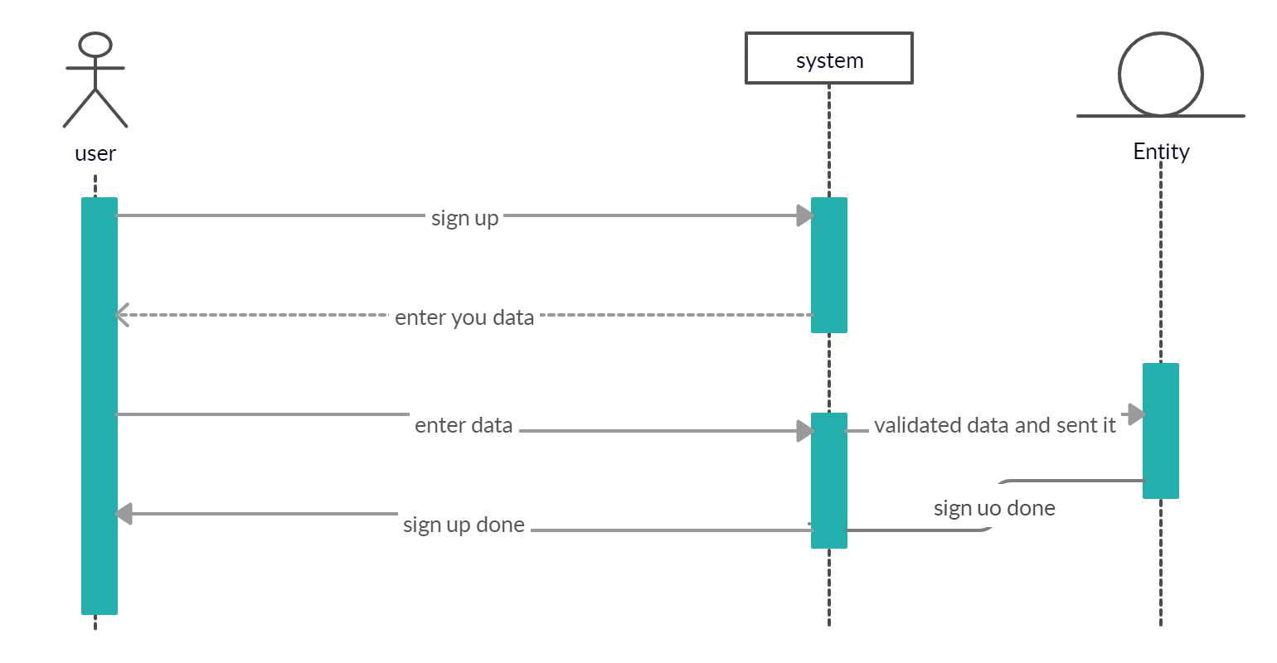

Rent bike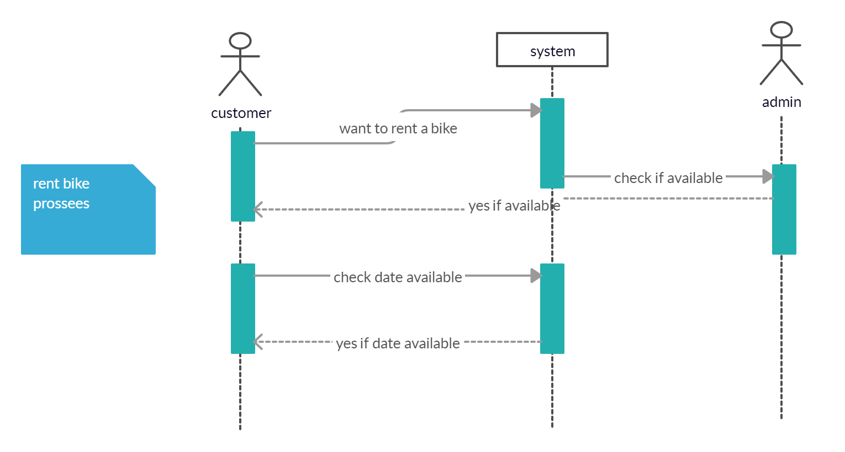

Sell bike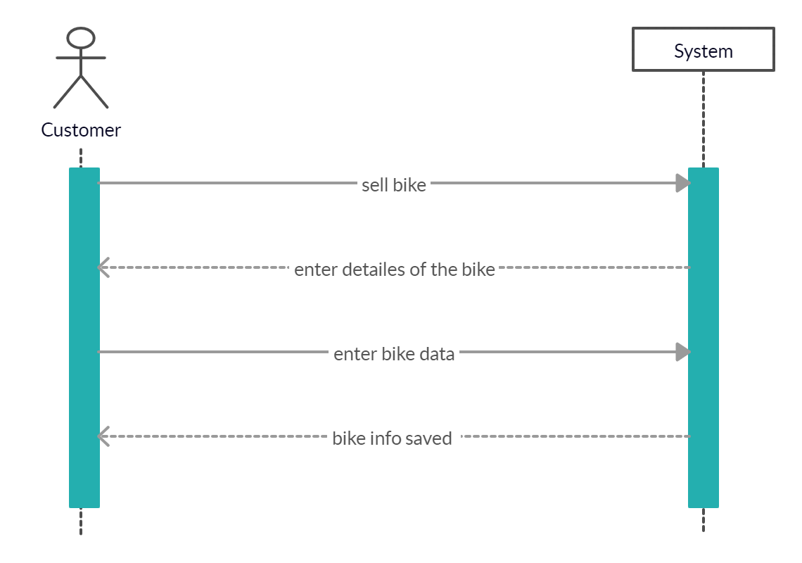

Service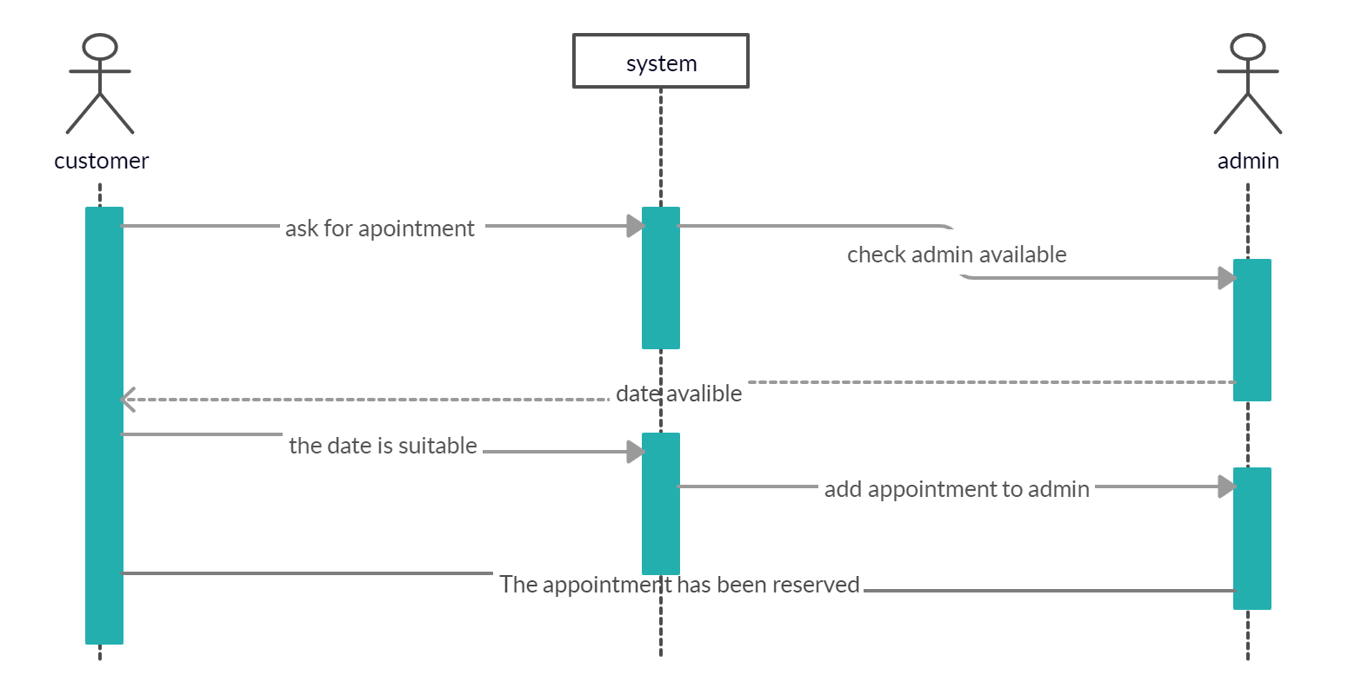

h) Collaboration Diagrams

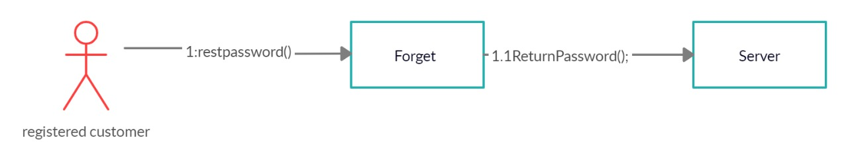

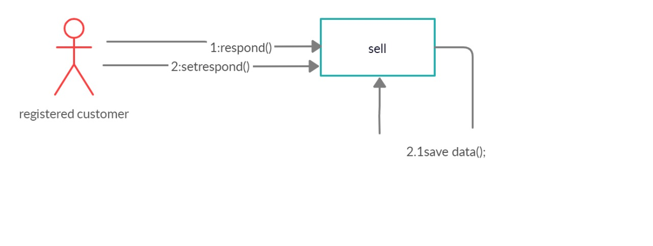

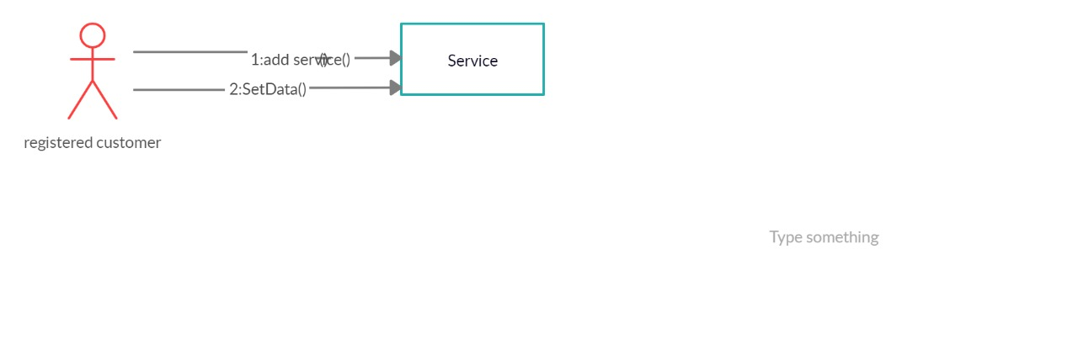

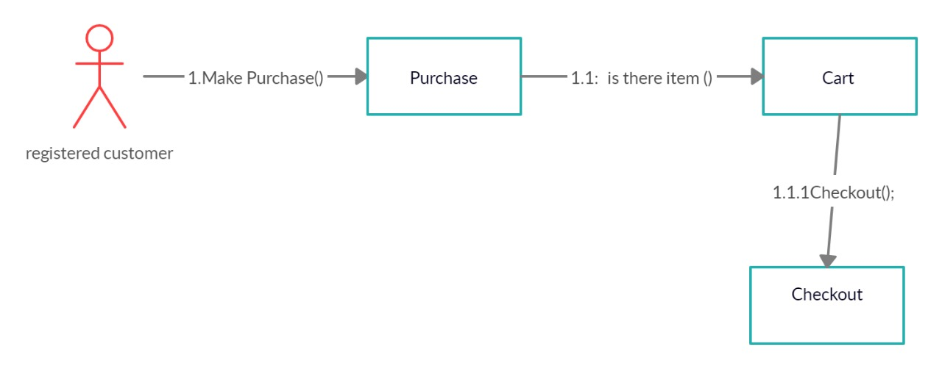

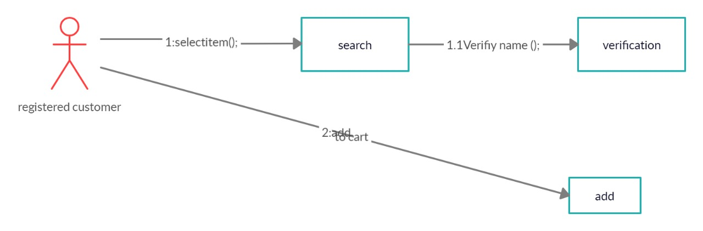

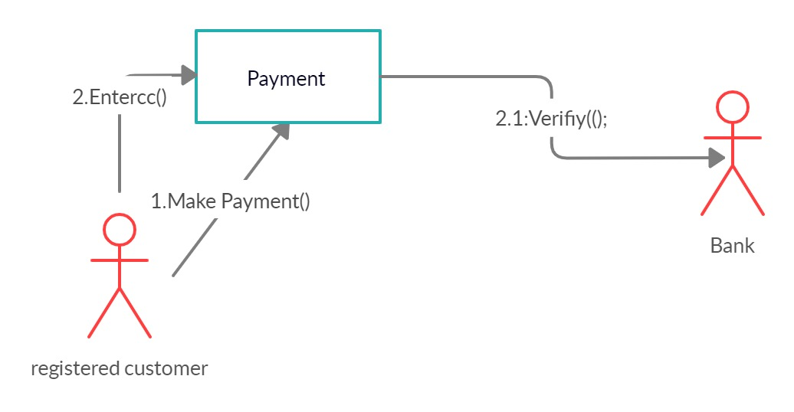

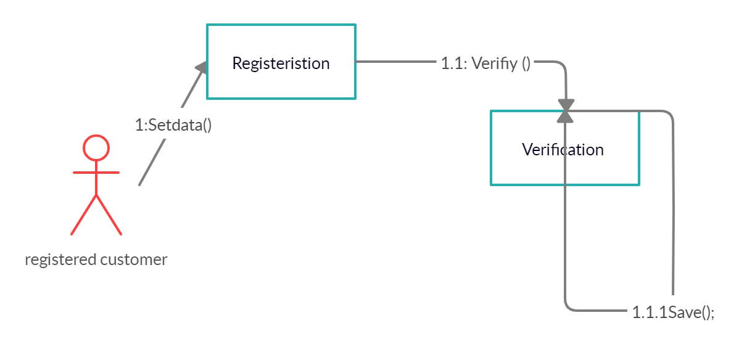

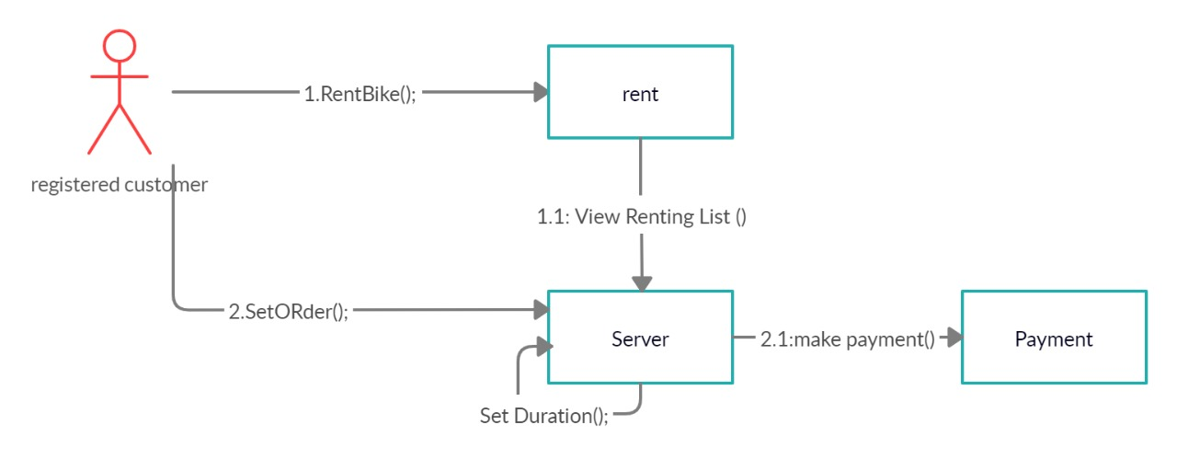

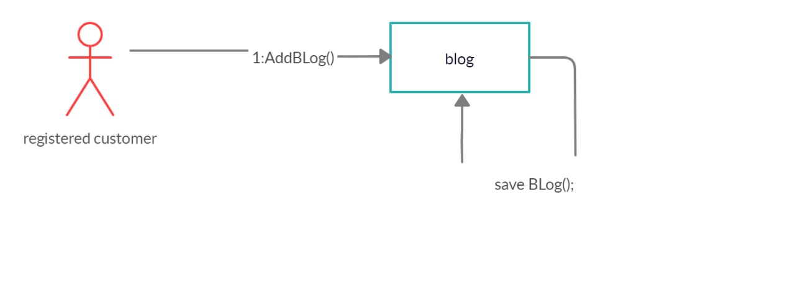

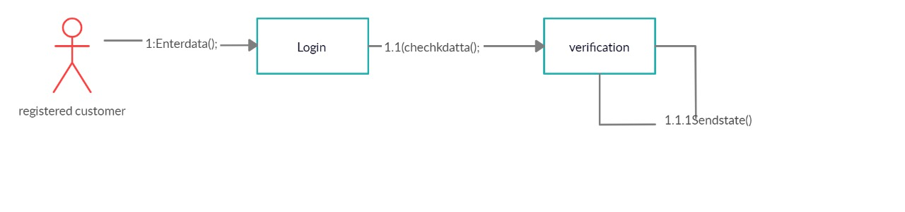

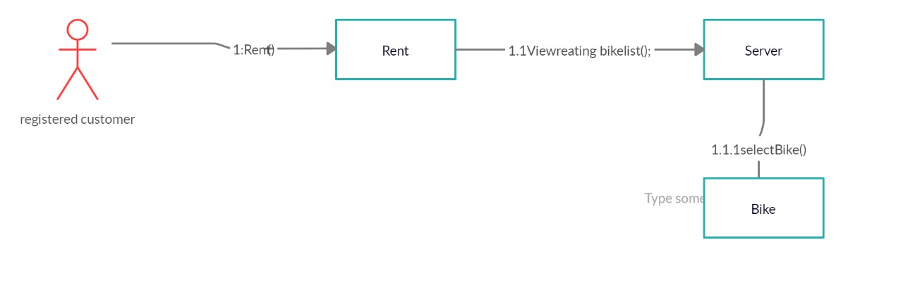

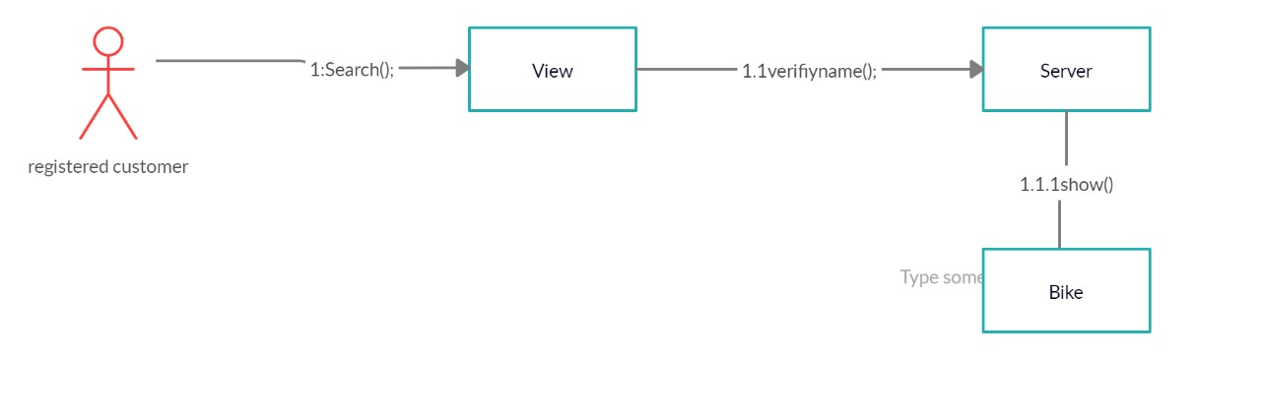

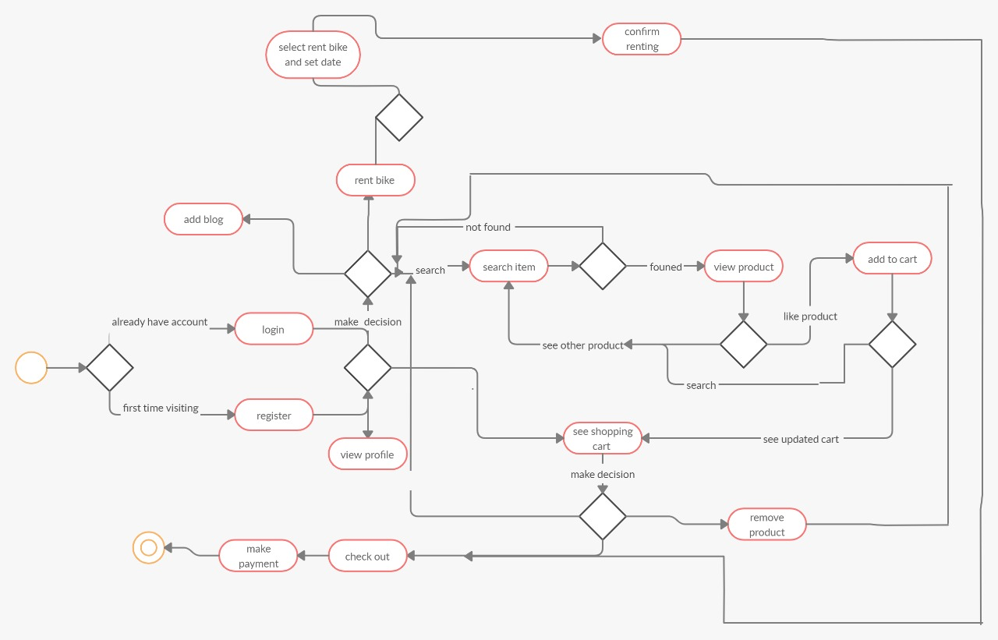

I)

we depends on Actor class and use-case class Strategies As the message will send to the software object crossponding to real world actor as in login use case, set time for service UC and set tax use case, and use-case class as we define a new class for each use case

Advantages of Actor class:

1. It has clear structure than one central class

Disadvantages of actor class

1. Traceability is more difficult than one central class
2. Limitation reusability
3. There is a further complication when there are two actors that can initiate an interaction

Advantage of use case class

1. Overcome the reuse limitation of actor class
2. Using use case object let you change or replace software to implement a given scenario so as to minimize the effects upon the core concepts
3. Use case object provides traceability from each use cases to class so each use case can understand in isolation

Disadvantages of use case class

1. Large number of extra class must be defined
2. Many of use case classes can be very similar, resulting in duplicated code and more difficult maintenance

j)

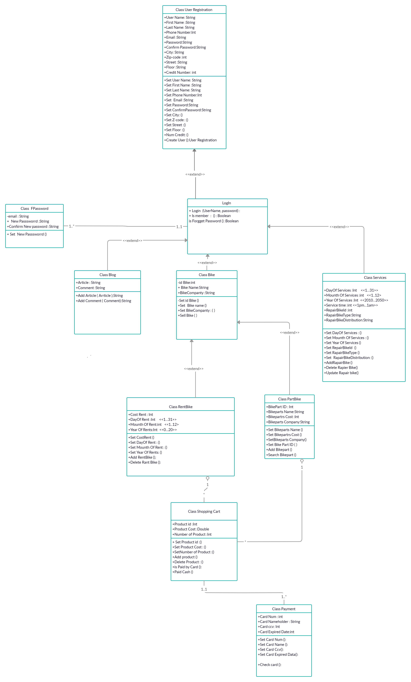

k) Design Patterns Applied

l)

